

***ista|*NET**

**Customer Summary Screen**

**User Guide**

**April 2009**

**Contents**

Introduction 5

Orientation to the Customer Summary Screen 6

Customer Hierarchy Trail 7

Customer Overview Panel 8

Account Alerts 8

Recent Activity Section 9

Common Tasks Bar 9

Customer Summary Tabs 10

Setting up User Preferences 11

Changing the Default tabs within the Customer Summary Screen 11

Showing and hiding tabs in the customer summary screen 12

Changing Communication Log Display Options 13

Customer Summary Tabs 16

Customer Information Tab 17

Viewing Customer Information: 17

Editing Customer Information: 18

Utility Accounts (ESI / LDC) Tab 22

Accessing the Utility Accounts Tab: 22

Utility Accounts Tab Overview: 22

Functionality Available within the Utility Accounts Tab: 23

View Transaction History: 24

Transaction History Panel Layout: 25

Performing a search on Transaction History: 26

Viewing Transaction Details: 27

Create Market Transaction: 28

Create Service Orders: 29

View Consumption: 30

Editing Premise Information: 31

Communication Log Tab 33

Accessing the Communication Log Tab: 33

Communication Log Tab Overview: 33

Communication Log Core Features: 34

To search for specific communication log note entries: 34

To view memo attached to a log entry: 35

To create new Communication Log Entries: 36

To edit an existing communication log note: 37

To add additional memos to existing communication log entries: 38

To resend a letter to a customer: 39

AR / Billing Tab 40

Accessing the AR / Billing Tab: 40

AR / Billing Tab Overview: 40

AR / Billing Core Features: 41

Invoice Management: 41

*To view invoice summary and detail level information:* 41

*To view Invoice TDSP Charges:* 43

*To email Invoice TDSP Charges:* 44

*To Print Invoice TDSP Charges:* 45

*To Email a Customer’s Invoice:* 46

*To view a Customer’s Invoice:* 47

*To reverse invoice charges:* 48

*To create an invoice adjustment via AR Summary History:* 49

Managing Adjustments 50

*To create an adjustment on the customer’s account:* 50

*To Remove an Invoice Adjustment:* 52

Managing Payments 53

*To view payment summary and detail level information:* 53

*To post payments to the customer invoices using FIFO:* 54

*To post payments to the customer invioces using SPEC:* 55

*To apply unapplied payments to a specific invoice:* 58

Viewing Accounts Receivable history 59

*To Print or email the customer’s AR History:* 59

Document Management 62

To access the Document Management screen: 62

To attach a document to a customer account 62

Customer Hierarchy 64

Organizational Master 64

To access the customer hierarchy maintenance screen 64

Customer Hierarchy Management Core Features: 65

To assign customers to a master customer: 65

To move customer from one master customer to another master customer 69

To create a new master level customer 70

To assign customers to be billed under a master customer 73

Locational Master 76

Locational Master Overview 76

Navigating through Services 76

Locational Master Customer Summary tabs 77

Cust Info Tab 77

Services Tab 78

Communication Log tab 79

*To Filter Communication Log records by Service Type* 79

AR Summary Report Tab 80

Budget Billing 81

Accessing the Budget Billing Management screen 81

Budget Billing Plan Core Features 82

To view the budget billing plan for the customer 82

To update the budget billing plan for the customer 83

To view the budget billing change log for the customer 88

# Introduction

Welcome to the ***ista***|NET Customer Summary Screen training. This User Guide will provide you a general orientation to the new Customer Summary Screen and instructions on how to:

* Use the new navigation features
* Manage Customer Information
* Manage the Customer Communication log
* Manage the Features and Functionality on the AR / Billing Tab
* Manage the Features and Functionality on the ESI List Tab

You can access the Customer Summary Screen from either the General Administration Menu, or from the Quick Launch Bar located at the top of your screen.

# Orientation to the Customer Summary Screen

Let’s begin with a general orientation. The image below is a screen shot of the general layout of the Customer Summary Screen.

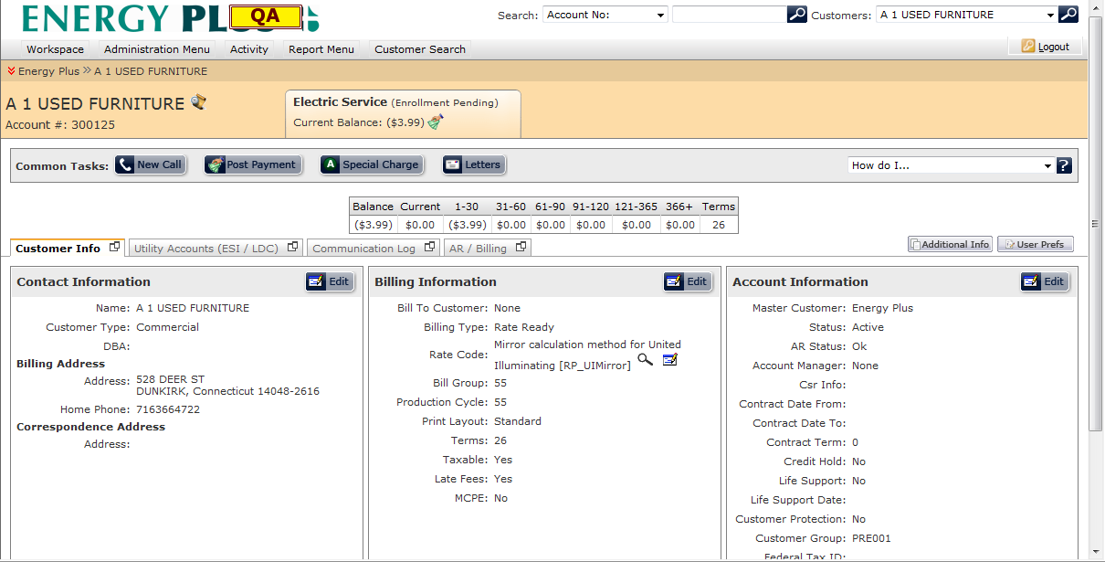

The customer summary screen is separated into several distinct sections which are listed below:

* Customer Navigation Bar
* Customer Overview Panel
* Account Alerts Section
* Recent Activity Section
* Common Tasks Bar
* Customer Summary Tabs

## Customer Hierarchy Trail



Located at the top of the customer summary screen is the customer hierarchy navigation trail which allows the user to access the customer hierarchy management screen. In addition, this section also displays all master customers relating to this customer.

The following key functions can be performed from this section:

1. A list of all customers that fall under a specific master customer can be seen by clicking Manage Hierarchy icon to the left of the master customer name.   
     
   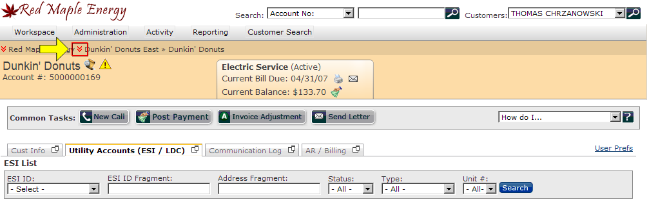  
   A drop down menu will display all customer accounts under that specific master customer. Clicking the customer name within the drop down menu will load the customer summary screen for the selected customer.   
     
   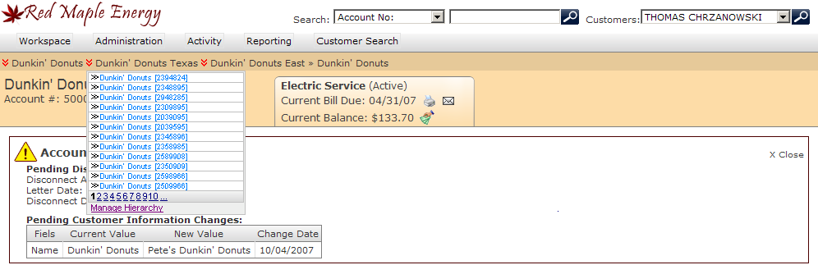  
   *If the master customer contains more than 12 customers, pagination navigation control will be loaded below the customer list.
2. The customer summary hierarchy screen can also be accessed directly by selecting the ‘Manage Hierarchy’ option under the Master Customer drop down menu.

## Customer Overview Panel



This section is located across the top of the page and is highlighted. On the left side you will see the customer name, account number, and master customer name (if applicable). To the right you will see a tab containing the type of service, the current status of the account (in parenthesis), the current bill due date, and the customer’s current balance.

For added convenience, the following key functions can be performed from this section:

1. View the Account Alerts for this account by clicking the **Click here to see the alerts for this account.** icon located to the right of the **customer name**. Clicking this icon will open a new panel below the primary customer information section. In addition, once the panel has been opened, the **Click here to see the alerts for this account.** icon will be hidden until the panel is closed.
2. View recent activities that were performed on this account by clicking the **Click here to view the most recent activity on this account.** icon located to the right of the **customer name**. Clicking this icon will open a new panel below the primary customer information section. In addition, once the panel has been opened, the **Click here to view the most recent activity on this account.** icon will be hidden until the panel is closed.
3. Print or view the current invoice online by clicking the  icon located to the right of the **current bill due** date.
4. Email the customer’s current invoice by clicking the**** icon located next to the print icon ****.
5. Post a payment by using the ****icon located next to the **current balance** amount. Clicking the  icon will open the post payment panel similar to the post payment button found within the common tasks bar.

## Account Alerts

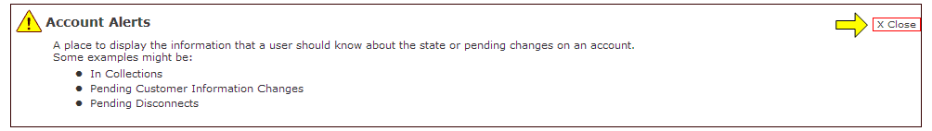

Just beneath the customer overview panel is a section entitled Account Alerts, which provides alerts to the user whenever the customer meets certain criteria. This section is primarily for informational purposes only and as such, no specific actions can be performed in this section. This panel will be hidden by default, unless there are valid account alerts for this customer. The Account Alerts section can be closed within the customer summary screen by pressing the  icon located at the top right corner of this container.

## Recent Activity Section

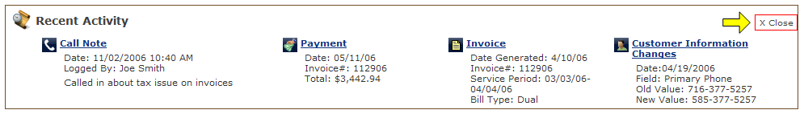

When a user opens the recent activity section, which is hidden by default, a new panel will load between the customer overview panel and the common tasks bar. This section will display the most recent activity that was performed on the account, categorized by the type of activity.   
  
The activity types which are displayed in this section are listed below:

1. Call Note – Displays the most recent call or memo that was entered into the system, as well as relevant note details. Clicking the *Call Note* title will open the communications tab within the customer summary screen.
2. Payment – Displays the most recent payment that was posted on the customer’s account and the relevant payment details associated with the payment. Clicking the *Payment* title will open the AR / Billing tab within the customer summary screen.
3. Invoice – Displays the most recent invoice that was released and printed in addition to the relevant details relating to this invoice. Clicking the *Invoice* title will open the AR / Billing tab within the customer summary screen.
4. Customer Information Changes – Displays the most recent change to the customer’s account information. Clicking the *Customer Information Changes* title will open the customer information tab within the customer summary screen.

## Common Tasks Bar



Beneath the Account Alerts section is the common tasks bar which will give the user quick access to various screens which are used frequently. These include:

* Creating a new customer communication log
* Posting payments
* Adjusting a customer’s account
* Sending Letters to Customers
* Accessing the Customer Summary screen help guide

The primary benefit of the common tasks bar is that it allows the user to retrieve data from different tabs without having to close and reopen windows constantly while performing a specific task.

## Customer Summary Tabs

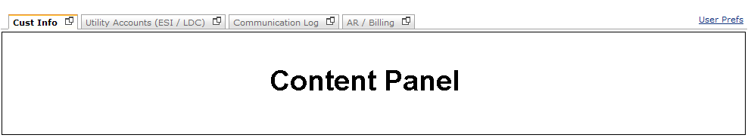

Beneath the Common Tasks bar you will notice a series of tabs. There are four primary tabs contained within this section which are listed below:

* Cust Info – Allows the user to view and edit customer contact, billing, and account information.
* Utility Accounts –Allows the user to view and manage all premises assigned to the customer. In this section, the user is also able to create and view transactions related to a particular premise.
* Communication Log – Allows the user to view and manage all communications made with the customer.
* AR / Billing – Allows the user to view the customer’s current account status, as well as the accounts receivable history of the customer.

These tabs are designed to increase efficiency in accessing relevant customer details by organizing data in logical segments and providing clear-cut navigation. The content in the panel below the customer summary tabs will change based on the tab that is selected.

Furthermore, clicking the  icon located at the top right corner of each tab will open the selected tab in a new window, which allows the user to review two panels at the same time. Once the user is finished with the new window, he/she can close window by clicking the close button  located within the customer overview section.



# Setting up User Preferences

Create the Customer Summary page that works best for you. User Preferences allow you to accomplish this goal. To access this page, click on the *User Prefs* link located to the right of the Customer Summary Tabs.

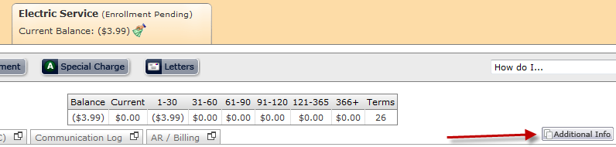

After the *User Prefs* link is clicked, the *Customer Summary Preferences* screen will pop up in a new window.

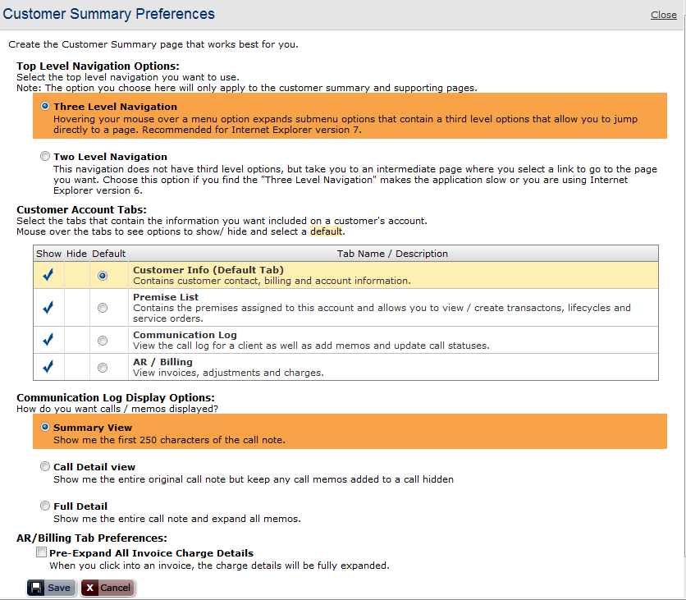

## Changing the Default Top Level Navigation Options

Selecting the “Three Level” navigation option will cause the menus to display like below.

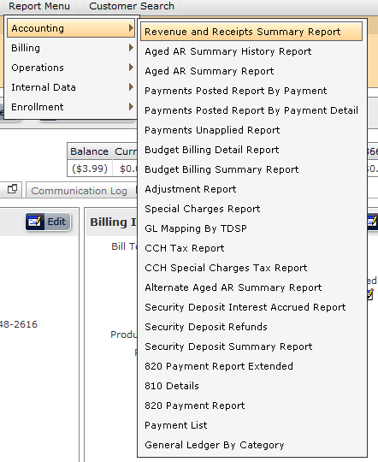

Selecting the “Two Level” option will cause the menus to display like below.

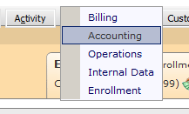

## Changing the Default tabs within the Customer Summary Screen

The default tab option will give the user the ability to specify which tab they wish to have opened when they first load the customer summary screen.

1. To change the default tab, the user must check the tab they would like to have loaded by default within the customer summary screen (Highlighted in red). Only one option can be checked at any given time.  
   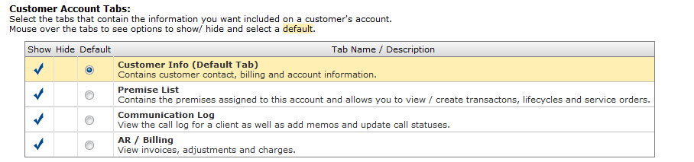
2. After the default tab has been selected by the user, the user can choose to either save his changes or cancel his pending changes (both options will close the window).

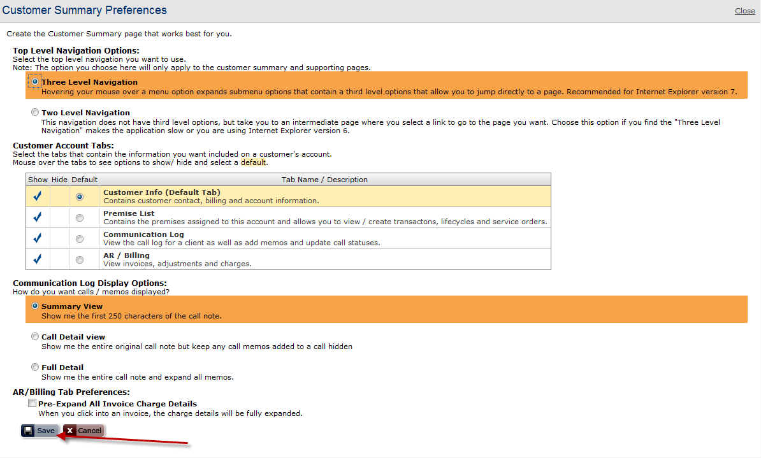

## Showing and hiding tabs in the customer summary screen

The *Customer Summary Preferences* section allows the user to select which tabs to show or hide within the customer summary screen. Tabs that are hidden will not be selectable from the customer summary screen unless the user changes his/her settings in the user preferences screen.

1. First, select all tabs to have visible by checking the appropriate checkboxes under the show column (red fields in the image below). Second, the user must also check the tabs they wish to have hidden (Red fields in the image below).

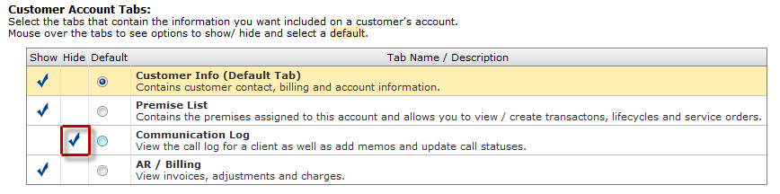

1. Once the tabs have been configured by the user, the user can either save his changes or cancel his changes (both options will close the window).



## Changing Communication Log Display Options

The communications log tab can be configured to display call note records in three distinct formats. The changes made to the display options will change the way in which communication log entries are shown within the communications log tab of the customer summary screen. These display options are listed below:

* Summary View – By selecting this option, the communication log tab will only display the first 250 characters contained within the communication log notes. All communication log notes longer than 250 characters will be truncated. A sample summary view record is shown below:



* Call Detail View – This option will display the communication log note in its entirety, but will continue to suppress all memos that were attached to this note. A sample call detail view record is shown below:

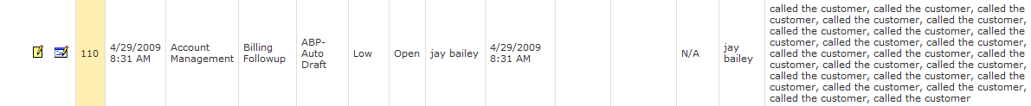

* Full Detail View – This option will display the entire communication log note, and will also automatically expand all memos attached to communication log records. A sample full detail view record is shown below:



The Communication Log Display Options can be accessed through the *Customer Summary Preferences* screen. The procedure to change these settings is listed below:

1. The communication log display options are located at the bottom of the customer summary screen, below the *Customer Account Tabs* section. Once the user selects the preferred display option, the selection will become highlighted and the radio button will be selected as indicated in the screenshot below:

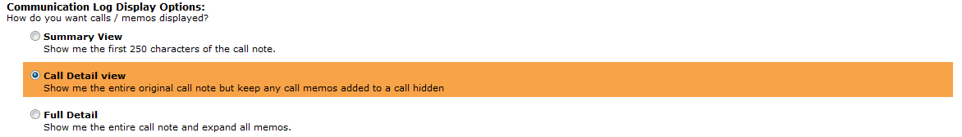

1. Once the preferred Communication log Display Options have been selected, the user can either save his changes or cancel his changes (both options will close the window).



# Customer Summary Tabs

As previously mentioned, the customer summary screen uses a new tab based navigation system. These tabs are designed to increase efficiency in accessing relevant customer details by organizing data into logical segments. In addition, the Customer Navigation bar, Customer Overview Panel, Account Alerts (if open), Recent Activity section (if open), and Common Tasks bar will remain visible regardless of the tab the user is accessing, granting the user immediate access to general account information and commonly performed tasks.

Currently, a customer’s account information is divided into four separate sections which are listed below:

* Cust Info – Allows the user to view and edit customer account information.
* Utility Accounts –Allows the user to view and manage all premises assigned to the customer. In this section, the user is also able to create and view transactions related to particular premises.
* Communication Log – Allows the user to view and manage all communications made with the customer.
* AR / Billing – Allows the user to view the customer’s current account status, as well as the accounts receivable history of the customer.

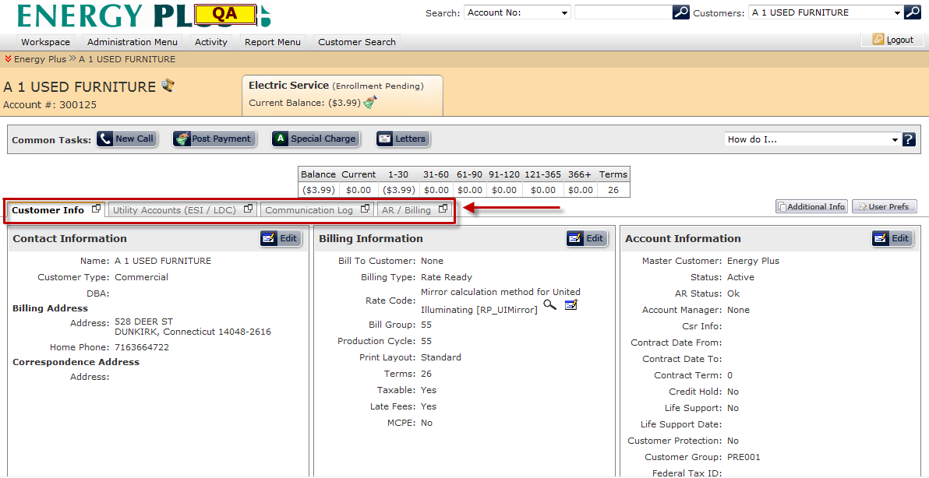

## Customer Information Tab

The customer information section of the customer summary screen grants the user the ability to view and edit a customer’s account information.

### Viewing Customer Information:

For improved visibility and access to specific data, the customer information tab is grouped into three categories:

* Contact Information (Highlighted in red)
* Billing Information (Highlighted in blue)
* Account Information (Highlighted in green)

To View Customer Information:

1. Access the customer summary screen by performing a customer search.
2. If the *Cust Info* tab is not the default tab, navigate to the customer information section by clicking on the *Cust Info* tab directly beneath the Common tasks bar.

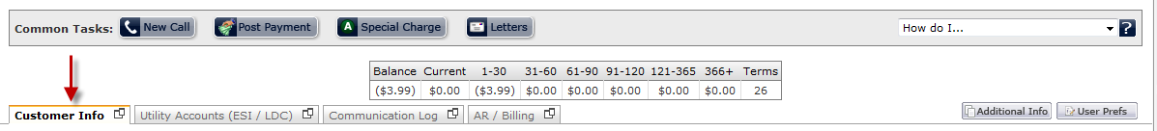

1. The customer information tab will now be loaded, allowing the user to view the customer’s contact, billing, and account information.

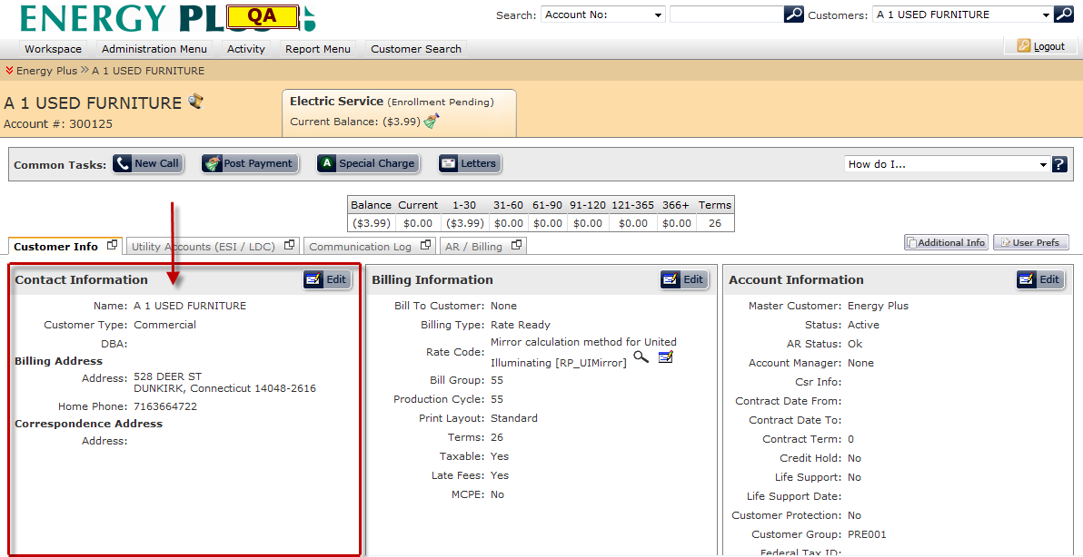

### Editing Customer Information:

In many cases, the user may need to update a customer’s account information that may have become out of date. This can be accomplished through the customer information tab of the customer summary screen. In addition, the user is able to make pending changes which are not applied to a customer’s record until the user-specified date.

To Edit Customer Information**:**

1. To edit the customer’s account information, click on the Edit button  located in the upper right-hand corner of the customer information section you wish to edit. *Note that you can edit each section independently.  
   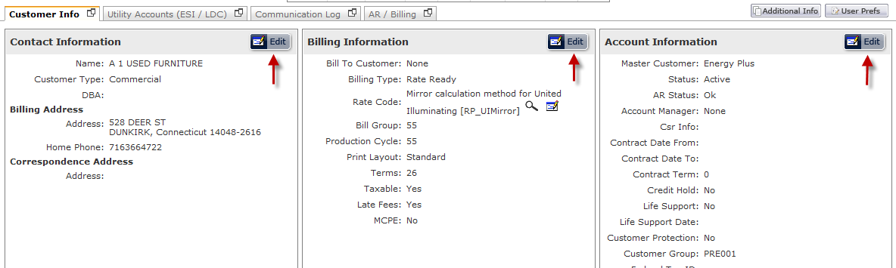
2. Once the edit button has been selected, the fields within that section will be editable as shown below:

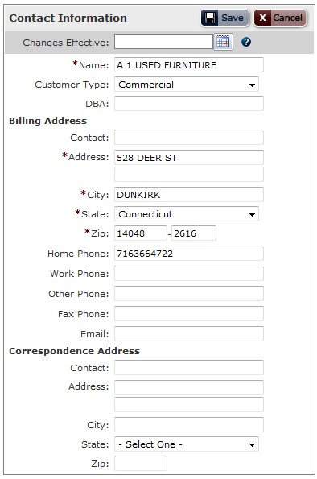

1. Make the desired changes to the customer’s account.

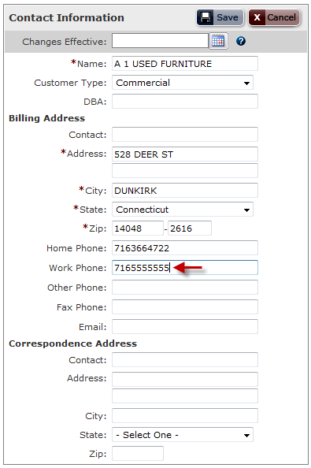

1. If the changes need to be made at a later date, the user must enter the desired date into the *Changes Effective* field. The user can populate the *Changes Effective* date in one of two ways.
   1. **Calendar Control –** The user can enter the *Changes Effective* date using the calendar control. Click the calendar button  to open the calendar control and select the desired date to auto-populate the *Changes Effective* date.  
      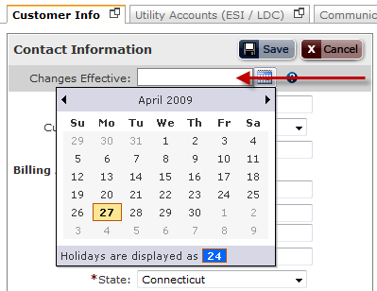
2. Click on the Save button  to save changes or click the Cancel button  to cancel all pending changes and go back to view mode.  
   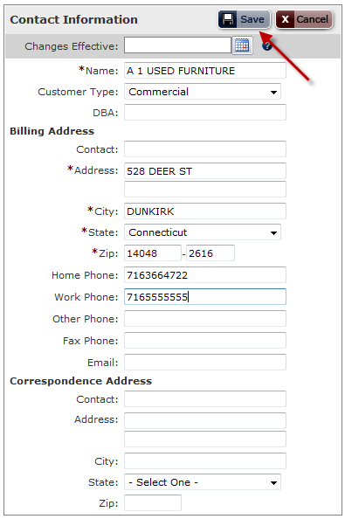
3. If the changes to customer information were saved with the *changes effective* field populated with a future date, the Account Alerts section will display the pending changes to this customer account.  
   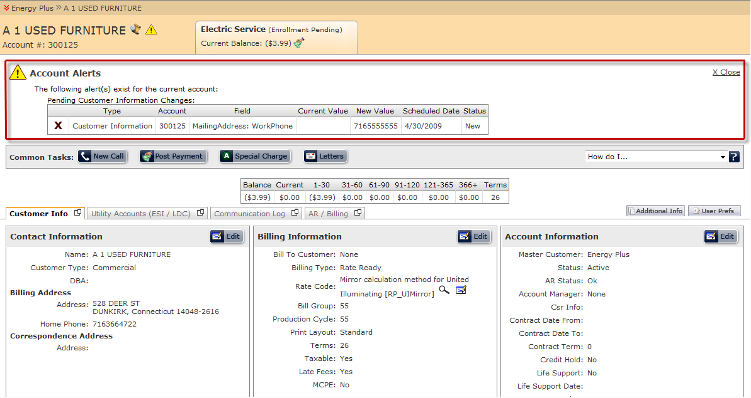

## Utility Accounts (ESI / LDC) Tab

The Utility Accounts tab contains the Service Address data and related transactions for all utility accounts that are currently enrolled or have been enrolled under the customer.

### Accessing the Utility Accounts Tab:

Begin by accessing the customer summary screen for a specific customer. If the Utility Accounts (ESI / LDC) tab is not the default tab, navigate to the Utility Accounts section by clicking on the *Utility Accounts (ESI / LDC)* tab directly beneath the Common tasks bar.



### Utility Accounts Tab Overview:

The Utility Accounts Tab consists of the following subsections. Note that some of these subsections are conditional and will only be displayed once certain conditions are met:

* Utility Account Search Bar – The topmost section within the Utility Accounts tab is a search bar which allows the user to find specific utility accounts. The search bar allows the user to filter results based on various criteria associated with a premise.



* Premise Level Alerts – In the event that no premises are currently enrolled under the customer, the following alert will be shown below the Utility Account Search Bar.



In the event that a premise search returned no results, the following alert will be displayed below the Utility Account Search Bar.



* Multiple Utility Account Premise View – For customers who have more than one utility account enrolled and active, a table view will display all active premises enrolled under the customer.

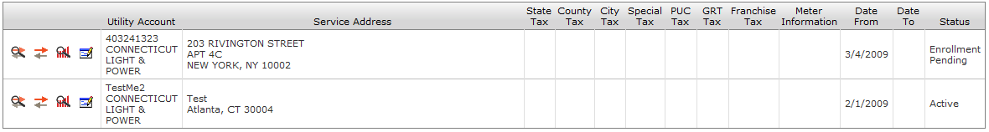

* Single Utility Account Premise View – If the customer only has one utility account or the utility account search only returns one result, the multiple utility account premise list view will be replaced with a “postcard view” of the single premise. The postcard view shows detailed premise information including a graph of historical consumption.

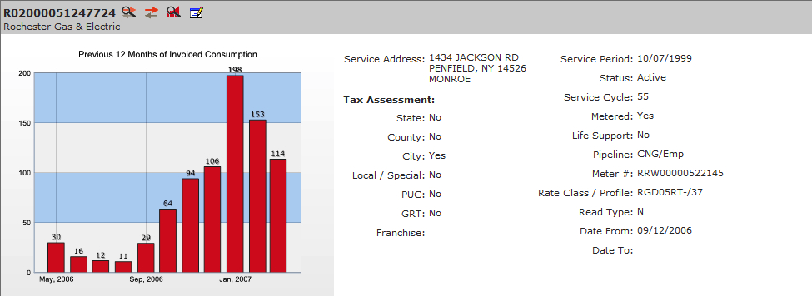

### Functionality Available within the Utility Accounts Tab:

Within the Utility Accounts tab, the user is able to perform a plethora of premise-based tasks. These tasks are accessible by clicking the appropriate icon as indicated below:

*  Transaction History: Allows the user to view the transactional history of a premise.
*  Create Market Transaction: Allows the user to create and send transactions to the market for a particular premise.
*  View Consumption: Allows the user to view consumption for a specific premise. In addition, the view consumption screen provides additional information such as meter information and market data.
*  Edit Premise Information – Allows the user to add or change premise information

The position of the action bar is dependant of the premise view. In the event that a customer has more than one premise, the action bar can be found on the leftmost column of the premise list.

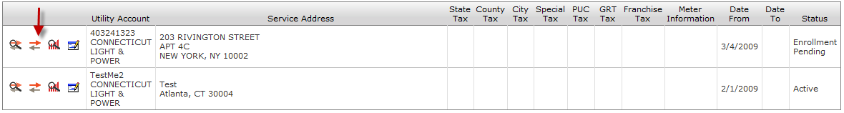

In the event where the customer has only one premise, the postcard view will be used. In this view, the action bar is located to the right of the Utility Account Number.

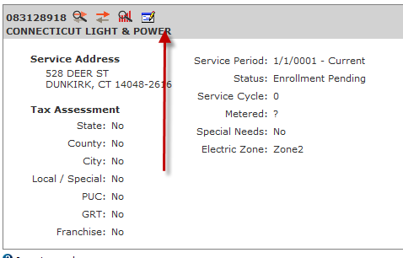

View Transaction History**:**

The transaction history section allows the user to view all relevant transactions for a particular premise. To open the transaction history panel, click the transaction history icon. The panel will open below the premise record.

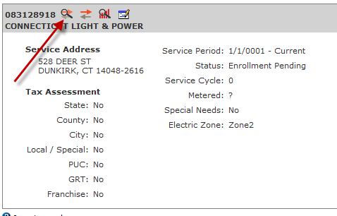

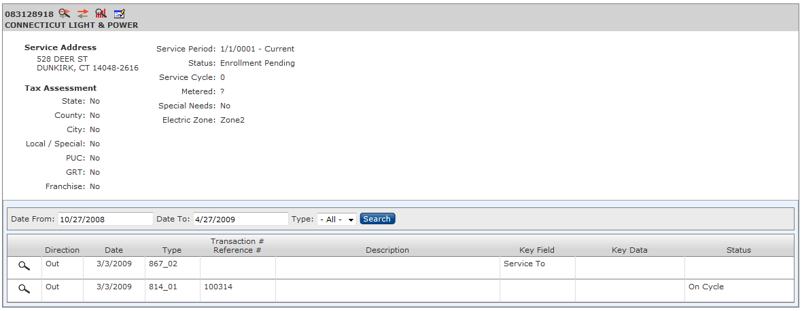

### Transaction History Panel Layout:

The Transaction History Panel includes a number of different features which are separated into difference sections.

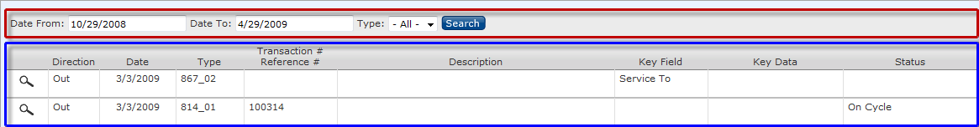

**Transaction History Layout Legend:**

* Transaction History Filter Bar
* Transaction Results Panel
* Pagination Control – (not shown)

**Navigation through Transaction Results:**

The Transaction Results panel displays all transactions that have either been sent or received for a specific premise. The maximum number of results that the panel will display is 20. However, if the system detects that there are more than 20 results returned, it will populate pagination controls beneath the result set.

**Pagination Control Guide**:

 - Go to the First Page (Disabled when on the first page)

 - Go to the Previous Page (Disabled when on the first page)

 - Go to the Next Page (Disabled when on the last page)

 - Go to the Last Page (Disabled when on the last page)

**In addition to the controls listed above, the user can click on the actual page number to access that specific page.

Performing a search on Transaction History**:**

In many cases, there may be a significant number of transactions that fall under one customer. The search functionality will allow the user to filter results by transaction type and transaction date.

To perform a search:

1. Open the Transactions History Panel.
2. Select the Transaction Type (if applicable).

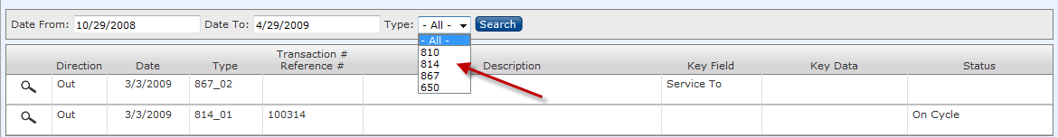

1. Users can modify the default filter on the Date from and Date to fields by keying in the desired dates.

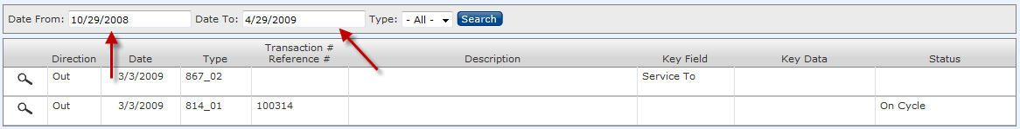

1. Once the search elements have been entered into the system, press the Search button Run your search. to filter the results.  
   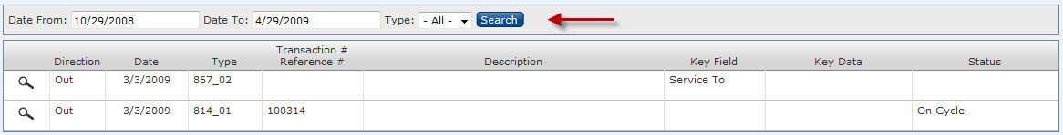

### Viewing Transaction Details:

There may be certain cases where the user must review the details of a transaction. The Transaction History panel gives users the ability to view raw market data if needed.

To view Raw Market Transaction Data:

1. Open the Transaction History Panel.
2. Click the View Market Data icon  to view transaction details. This will open up a panel showing market data. The data contained in this row is designed to promote efficiency and will only return data that is commonly requested when viewing this specific transaction type.

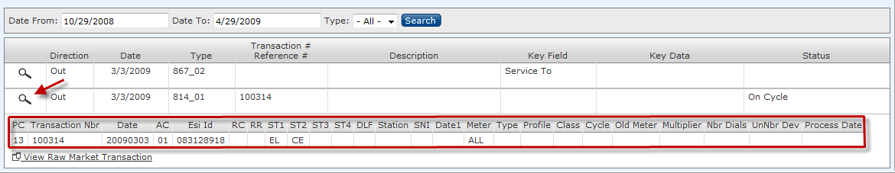

1. If the market data retrieved in step 2 is not sufficient, click the View Raw Market Transaction link to view the raw market data.

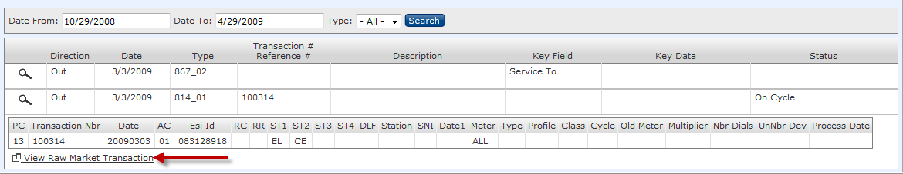

1. When the View Raw Market Transaction link is clicked, a new window will be opened which includes basic customer and premise information as a reference. Once the user has finished reviewing the transaction, pressing the close button  at the top right corner of the window will close window.

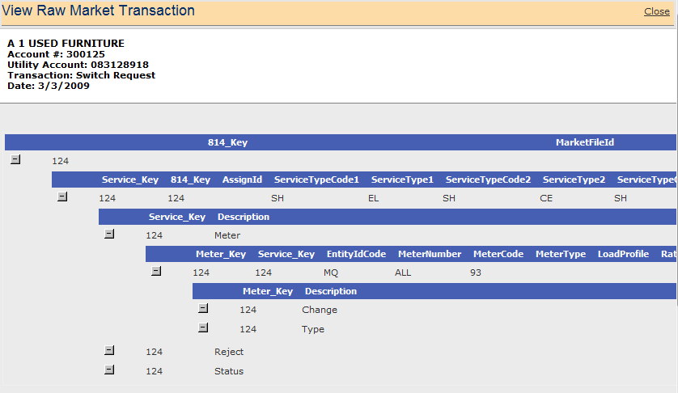

### Create Market Transaction:

The primary means of communication to the Retail Market is EDI transactions. Customer enrollments, terminations, monthly meter readings, distribution charges, move-ins, and switches all move through the market in this manner. Once a customer’s account has been created, market transactions can be created manually through the create transaction screen if required. Refer to the Create Transaction documentation if additional help is needed in creating market transactions.

To access the create transaction screen:

1. Click the create transaction [](http://istasearch/AppData/Desktop/customer%20summary/transactions/p1.html) icon to the right of the Transaction History icon. Clicking the Create Transaction icon will load the create transaction screen in a new window.

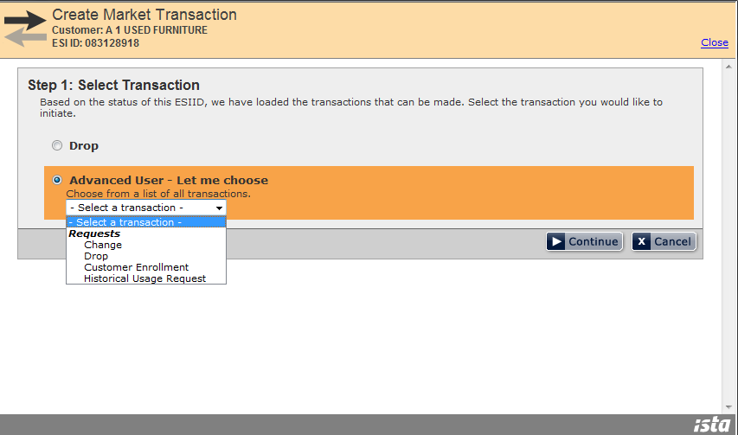

### View Consumption:

The View Consumption screen allows a user to view the meter information, final reads, and consumption information for a specific customer and premise. From this screen, the user will also have the ability to determine whether consumption has been imported and whether or not consumption currently in the system has been invoiced yet. The overall layout and design of this screen will remain unchanged.

To access the View Consumption screen:

1. Begin by clicking the View Consumption icon  located to the right of the create service order icon. Clicking the View Consumption icon will open the View Consumption screen in a new window.

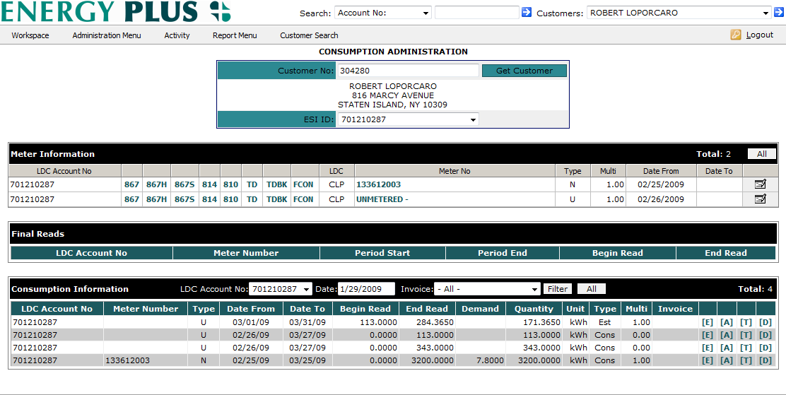

### Editing Premise Information:

In the Texas electricity market it is important to understand that the service address data belongs to the TDSP and therefore cannot be modified. If you discover that the Service Address is incorrect, contact the TDSP and request them to change their records.

The three data elements that are managed by the Retailer include:

* TDSP Template – manages which TDSP charges are billed to the customer
* Rate Code – if used, overrides the rate code at the customer level
* Tax Assessment – determines which taxes are assessed

To access the Edit Premise Screen:

1. Begin by clicking the Edit Premise icon  located to the right of the View Consumption icon. Clicking the Edit Premise icon will open the Edit Premise screen in a new window.

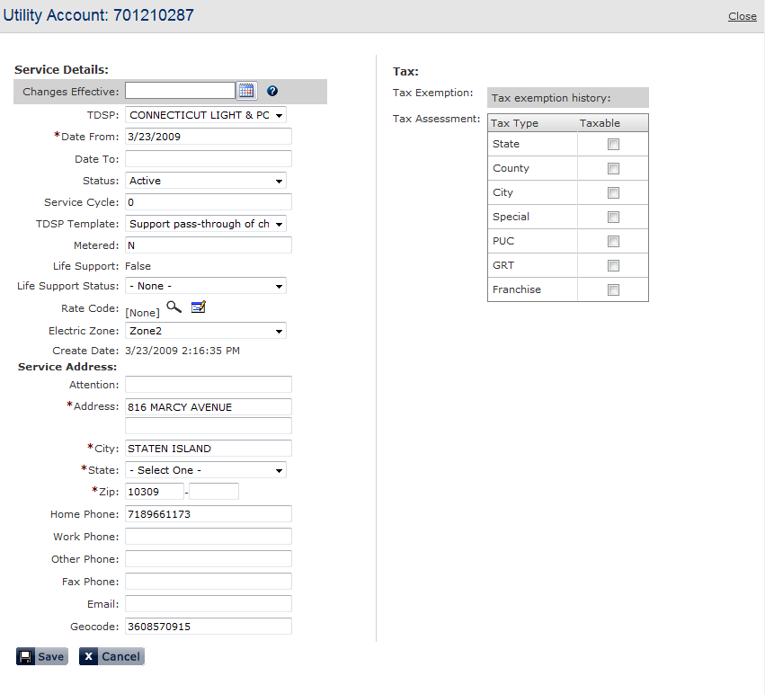

1. Make the desired changes to the premise and click the *Save* button  to save the changes to the premise record and close the window. Pressing the *Cancel* button  will discard any changes made and will close the window.  
   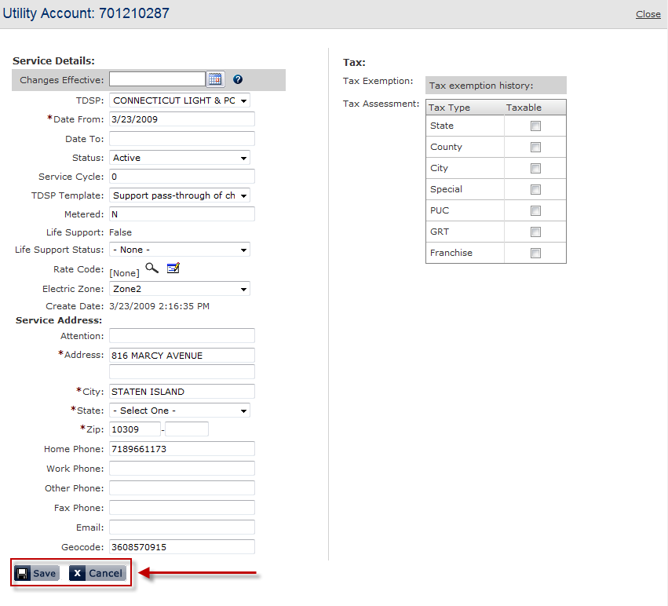

## Communication Log Tab

The Communication Log tab is where users can manage notes to customer calls. As each new call is created, it is logged as a separate line item and the primary details of each note are visible for ease of review and research.

### Accessing the Communication Log Tab:

Begin by accessing the customer summary screen for a specific customer. If the Communication Log tab is not the default tab, navigate to the appropriate section by clicking on the *Communication Log* tab directly beneath the Common tasks bar.

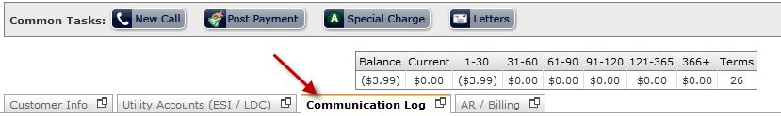

### Communication Log Tab Overview:

The Communication Tab consists of the following subsections. Note that some of these subsections are conditional and will only be displayed once certain conditions are met.

* Communication Log Tab Search Bar: Located at the top of the Communication Log tab is a search bar which allows a user to search communication log notes. When text is entered into the search box and the user clicks the search button , the system will search the *notes* field of all communication log notes and return only notes that match the search critera..



* Communication Log Alerts: In the event that the communication log search returned no results, the following alert will be displayed below the search bar.



* Communication Log Content Panel: The communication log content panel includes all communication log records that have been created for a particular customer. If a search was preformed previously, only the search results will be displayed in this panel. 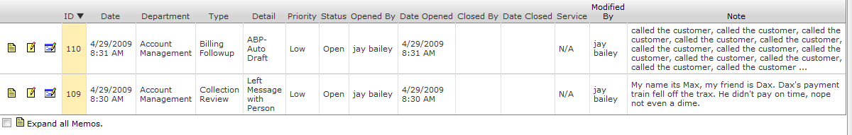

### Communication Log Core Features:

From the Communication Log tab in the customer summary screen, the following actions can be performed:

* + Search for specific communication log note entries
  + View memos attached to a log entry (if applicable)
  + Create new Communication Log Entries
  + Edit an existing communication log note
  + Add additional memos to existing communication log entries
  + Send letters to Customers

To search for specific communication log note entries**:**

1. Enter a search string into the search box located at the top of the Communications Log. Once a search string has been entered, click the Search button  to filter the results.

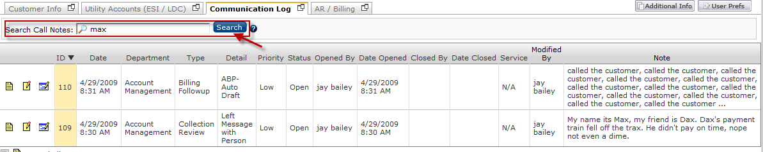

1. If the search has found valid results, the system will display the matching records.

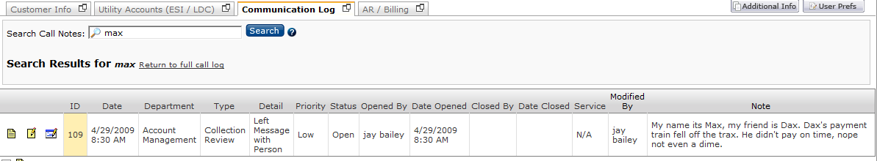

If the search has returned no results, an alert will be displayed.

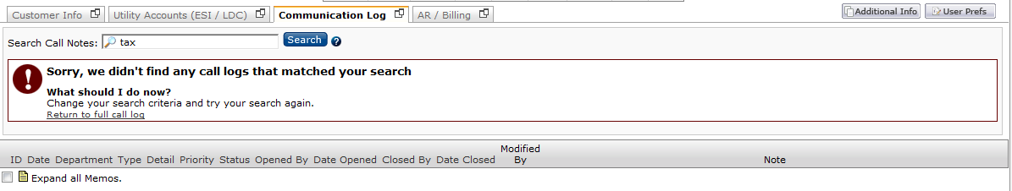

1. If the user wishes to remove the search filter and view all communication log records, clicking the  link will remove the filter and display all records.

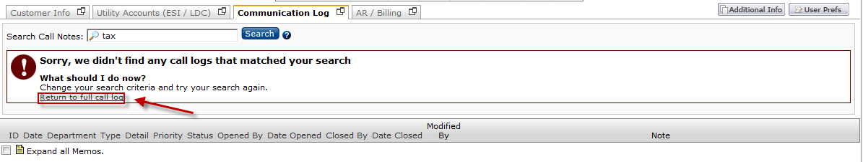

To view memo attached to a log entry**:**

1. There may be cases where other users have attached memos to communication log entries to give follow-up or additional information. Log entries in the system with memos attached will have an indicator icon  displayed in the leftmost column of the Communication Log table.

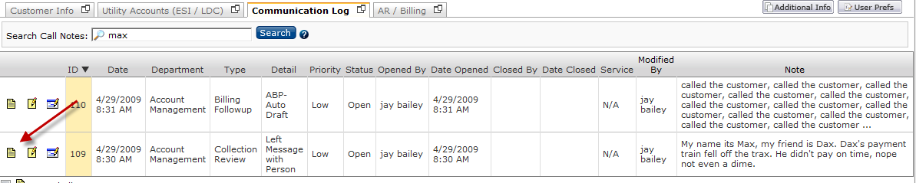

1. Click on the on the indicator icon  to view the memos attached to that specific communication log entry. The additional memos will be displayed below the communication log entry.

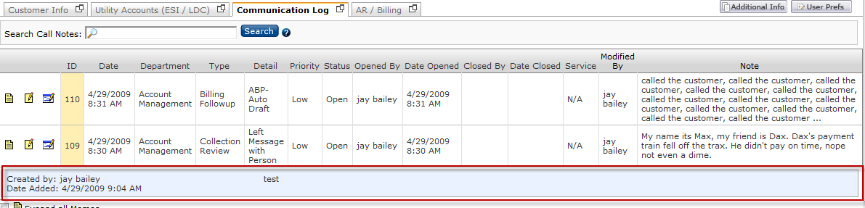

1. The user also has the ability to display all memos that are attached to communication logs. This can be done by clicking the checkbox entitled *Expand all Memos*.   
   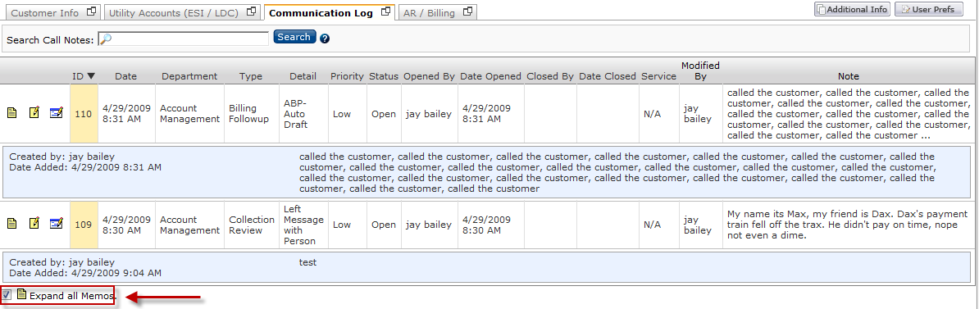

To create new Communication Log Entries**:**

* + 1. A new communication log entry screen can be accessed at any time while in the customer summary screen by clicking the new call button , which is the leftmost button on the common tasks bar.

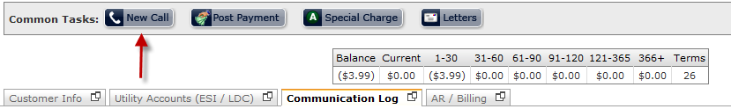

* + 1. Once the New Call button has been clicked, a panel will open between the common tasks bar and the Customer Summary Tabs. This panel will allow the user to create new entries in the communication log tab.

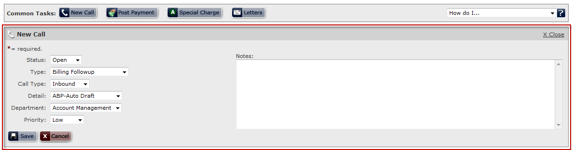

* + 1. Select the note status, note detail, note type, note department, and call type through the appropriate drop down menus provided.

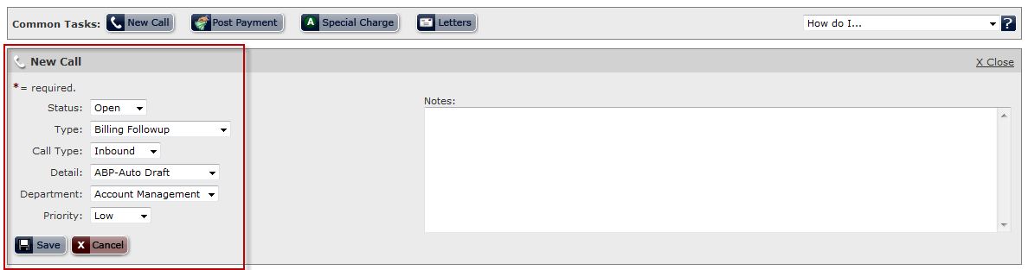

* + 1. Type a detailed description of the communication for which the log entry was made. It may also be beneficial to include keywords into the note, which will help maximize the effectiveness of the search feature.

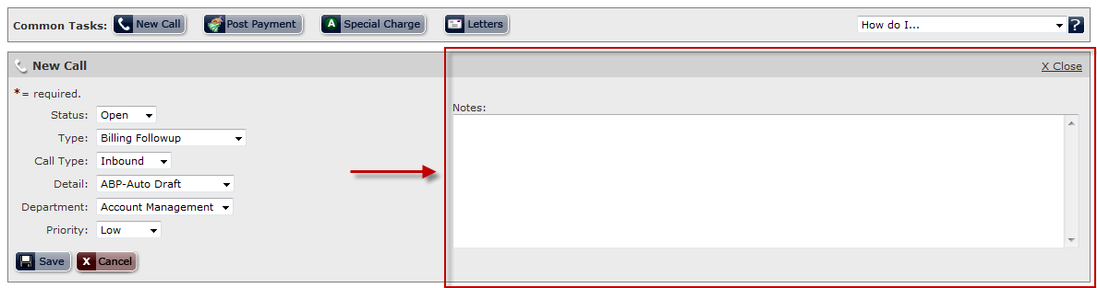

* + 1. Once all fields have been entered, click the save button  to create a new communication log entry and close the panel. The new communication log entry can be viewed through the communication log tab. Click the Cancel Button  to discard the changes and close the *New Call* panel.

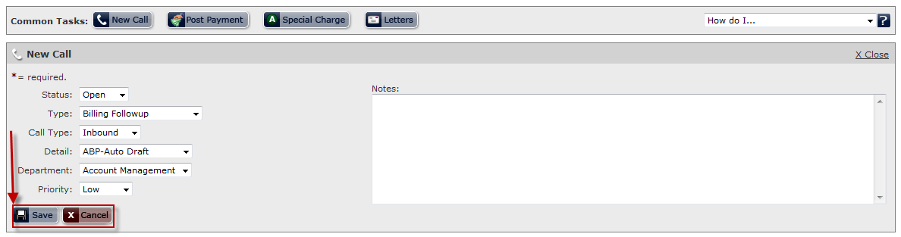

To edit an existing communication log note**:**

1. To edit the call status on an existing memo, click the Edit Call Status button  located in the leftmost column of the communication log entry that you wish to edit.



1. Once the Edit Call Status button has been clicked, a panel will appear below the communication log record you wish to edit. This panel will only allow the user to set certain values through a drop down menu.

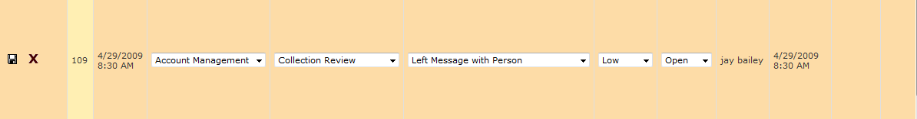

1. After properly updating the communication log entry, click the Save icon  to save your changes to the record. To discard changes, click the Cancel icon.

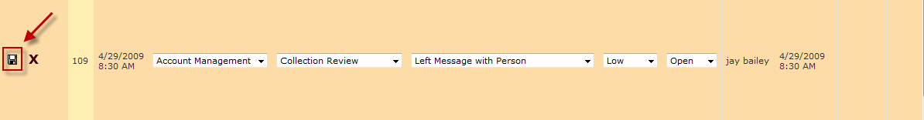

* + - 1. Once the user clicks the Save button, the panel will close and the changes will be reflected on the communication log record.



### To add additional memos to existing communication log entries:

1. Click the Add memo icon  located in the leftmost column of the communication log entry that you wish to add a memo to.



1. After the Add memo icon has been clicked, a panel will appear below the communication log record you wish to add the memo to. Also note that the department, type, and detail fields will be populated from the parent log record. 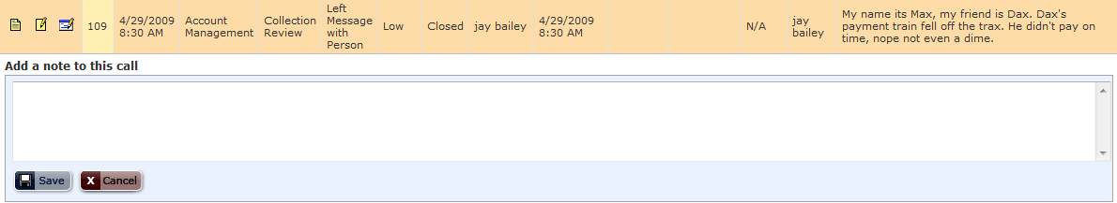
2. Type the note to be attached in the space provided.  
   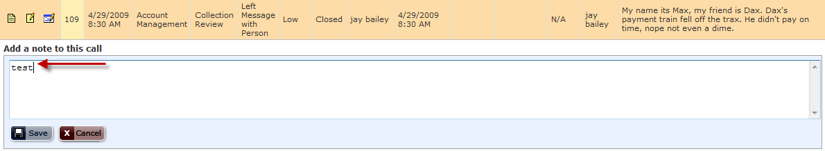
3. Click the Save button  to save the memo. Saving the memo will create a new note record and will attach the memo to the parent log entry. Click the Cancel button  to discard changes and close the panel.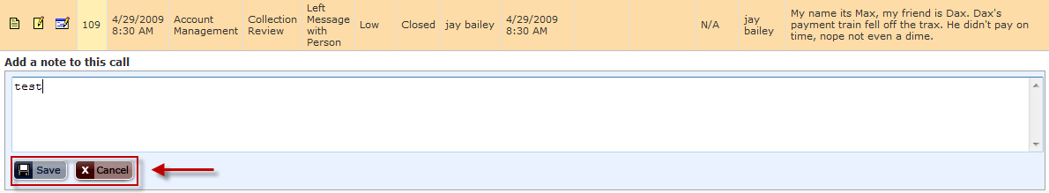
4. Upon saving, the new memo can be found below the parent communication log entry.

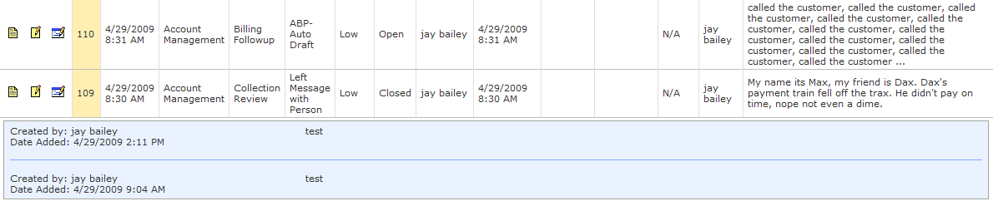

### To send a letter to a customer:

1. A letter can be sent to a customer by clicking the Letter button , which is the rightmost button on the common tasks bar.  
   
2. Once the Letter button has been clicked, a panel will load below the Common Tasks bar.

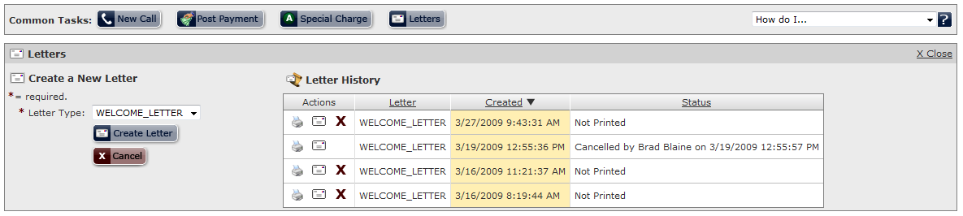

1. Select the letter type of the letter you wish to send to the client from the drop down menu. **Only letters that have been previously generated for this specific customer are available in the drop down menu.

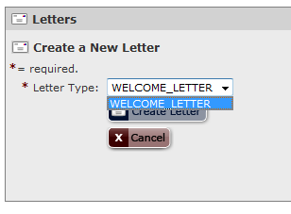

1. Once letter type has been selected, press the Create Letter button  to send the letter; otherwise, click the Cancel button  to discard the changes and close the window.  
   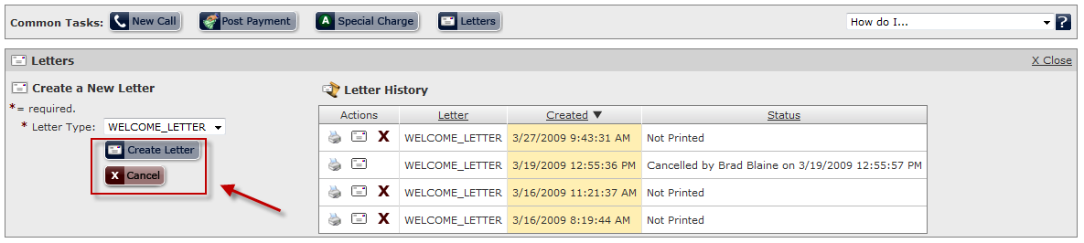

### To resend a letter to a customer:

1. View letter.
2. To Resend a letter to a customer click on the envelope icon . This will cause a pop up alert message to show. A user will have to click ok to have the letter queued to be resent.

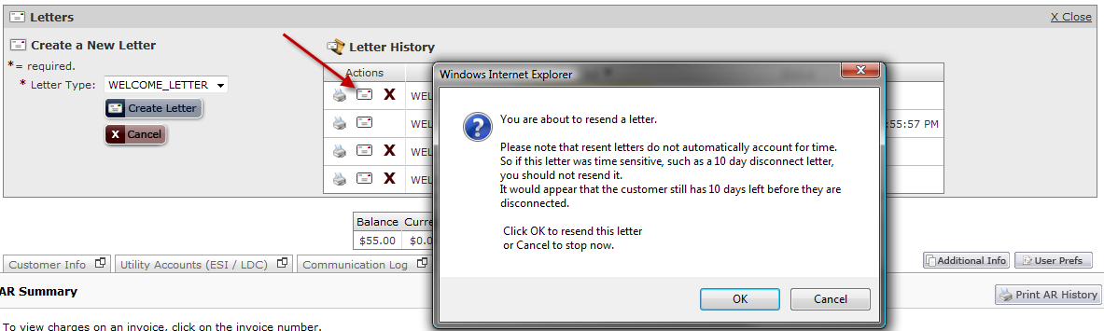

1. Cancel sending a letter that has not been printed click on the “cancel” icon . This will removed the letter from the print queue and will prevent it from being sent.

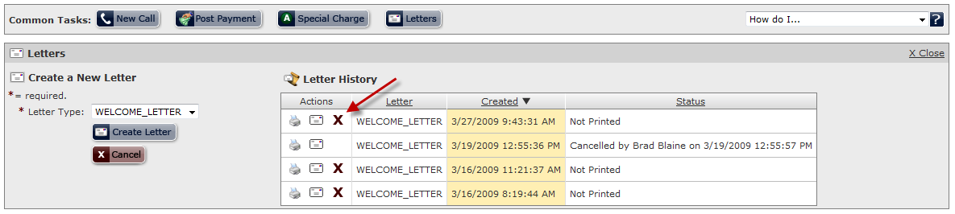

## AR / Billing Tab

The AR/Billing Tab is where customer financial transactions are located. From this screen, the user is able to view and manage customer invoices and payments.

### Accessing the AR / Billing Tab:

Begin by accessing the customer summary screen for a specific customer. If the AR / Billing tab is not the default tab, navigate to the Accounts Receivable section by clicking on the *AR / Billing* tab directly beneath the Common tasks bar.

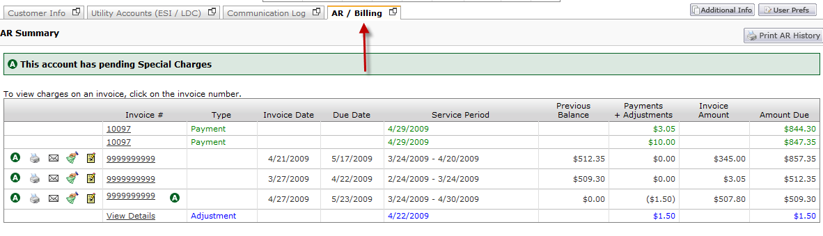

### AR / Billing Tab Overview:

Below is a screenshot of the general layout of the AR / Billing tab.

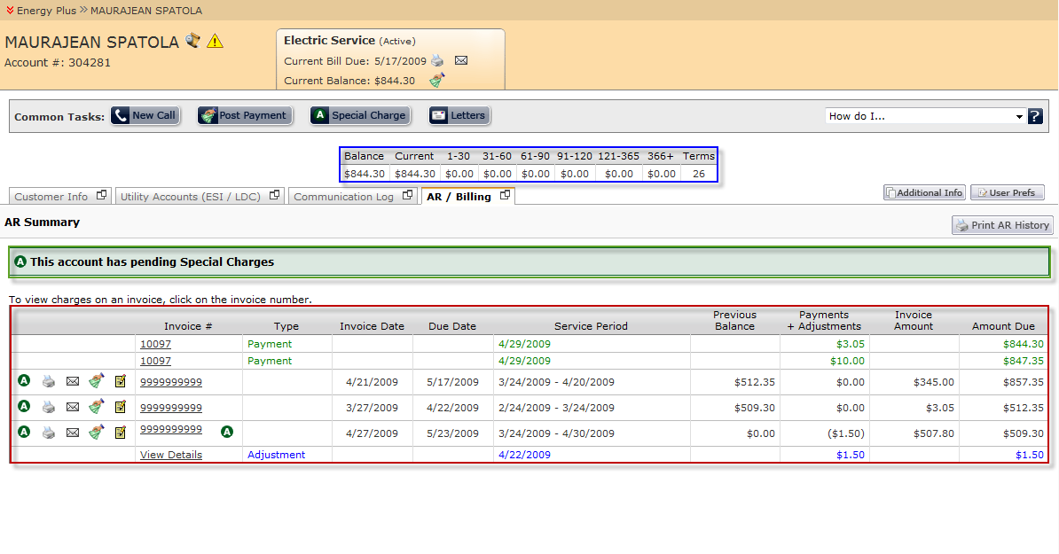

**AR / Billing Tab Legend:**

* Account Summary – The account summary table gives the user a summary view of the customer’s current financial status.
* Accounts Receivable alert – This section displays all invoice adjustments/special charges that are currently pending and will be applied to the next invoice created.
* Accounts Receivable Summary History – In this section, the user can view and manage financial transactions relating to a specific customer.

### AR / Billing Core Features:

From the AR / Billing tab in the customer summary screen, the following actions can be performed:

**Invoice Management**

* + View Invoice summary and detail level information
  + View Invoice TDSP Charges
  + Email TDSP Charges
  + Print TDSP Charges
  + Email a Customer’s Invoice
  + View a Customer’s Invoice
  + Reverse Invoice Charges
  + Create an Invoice Adjustment
  + Reverse Late Fee

**Manage Adjustments**

* Create an Adjustment on the customer’s account
* Remove an Adjustment from the customer’s account

**Manage Payments**

* View Payment summary and detail level information
* Post Payments to customer invoices using FIFO
* Post Payments to customer invoices using SPEC
* Post Payments to the customer account
* Apply unapplied payments to a specific invoice

**Viewing Accounts Receivable history**

* To Print or email the customer’s AR History

### Invoice Management:

#### *To view invoice summary and detail level information:*

1. From the Accounts Receivable Summary History, click the invoice number of the invoice you wish to view.

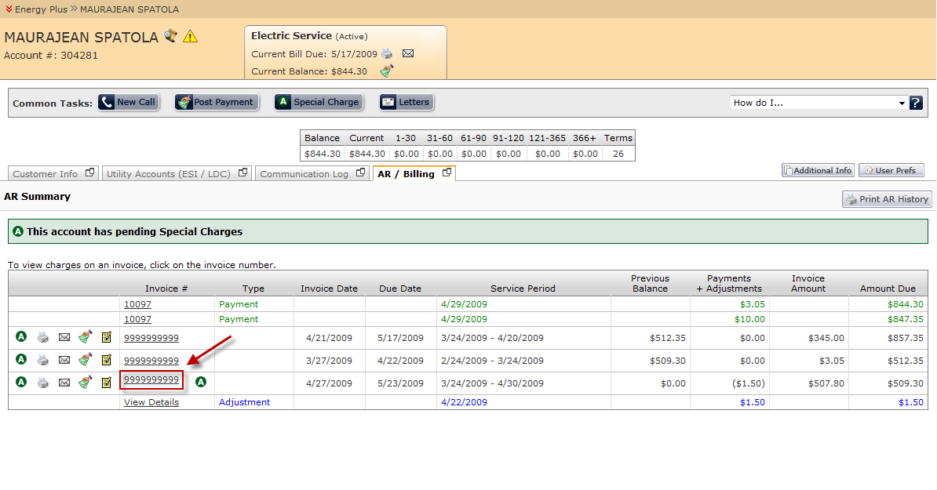

1. After the invoice number has been selected, the details to the invoice will open in a panel directly below the invoice record. By default, the invoice details are summarized by the type of invoice charge.

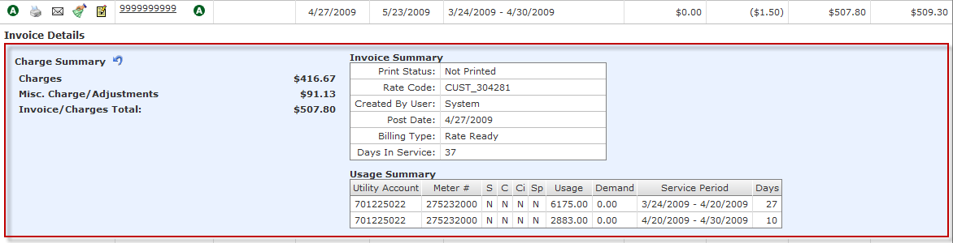The invoice detail panel is organized into three different sections. The charge summary section lists all charges that were included on this particular invoice. The sum of all charges in this section should equal the invoice total. The invoice summary section lists generic invoice information, such as the days in service and the invoice post date. The usage table shows detailed consumption information from which consumption charges were calculated.

1. The charge summary by default sums up charges by the charge type. To break down these charges by line item, click the title of the charge type. The detailed line items will populate below the summary charge title.

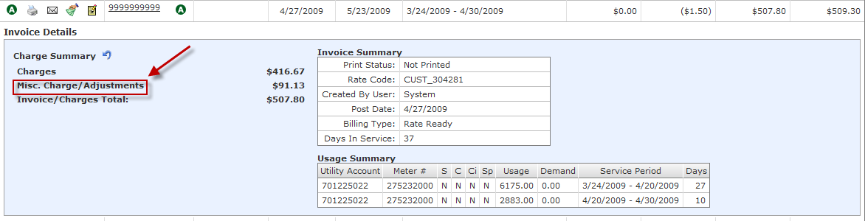

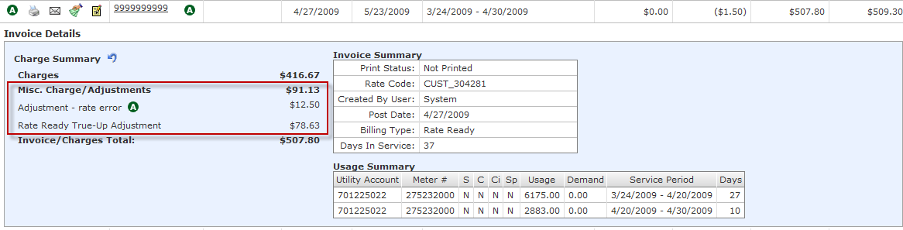

1. To close the invoice detail view, click the invoice number for the invoice you wish to close.

#### *To Email a Customer’s Invoice:*

1. From the Accounts Receivable Summary History, click the letter icon  located to the left of the invoice number you wish to send.

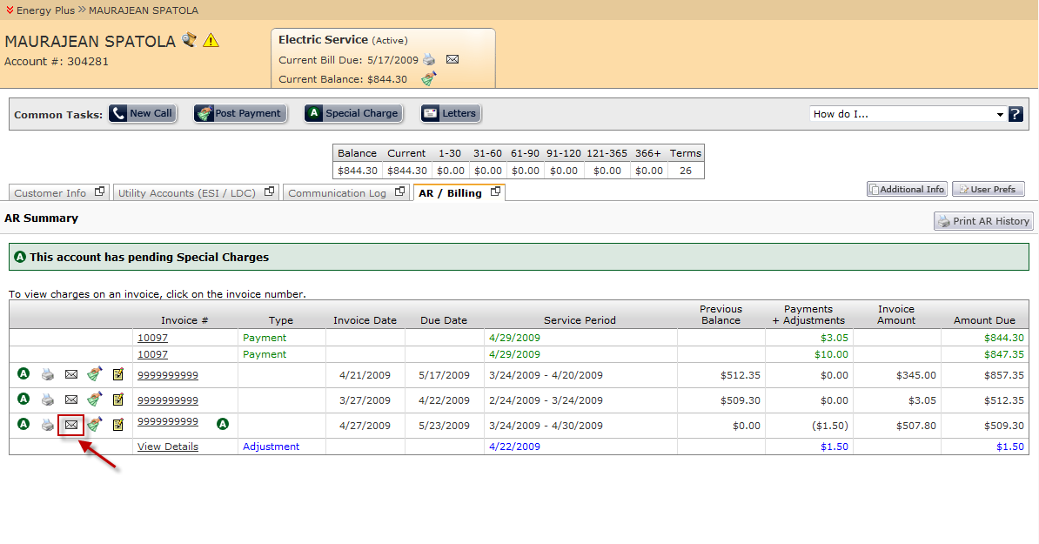

1. After the letter icon has been clicked, a new window entitled “Email Invoice” will open. This window will populate the Send to email address (if found under the customer’s account information), the Sent from email address (logged in user’s email address), and a general subject line. The user is free to change any of the fields in this form prior to sending the email.

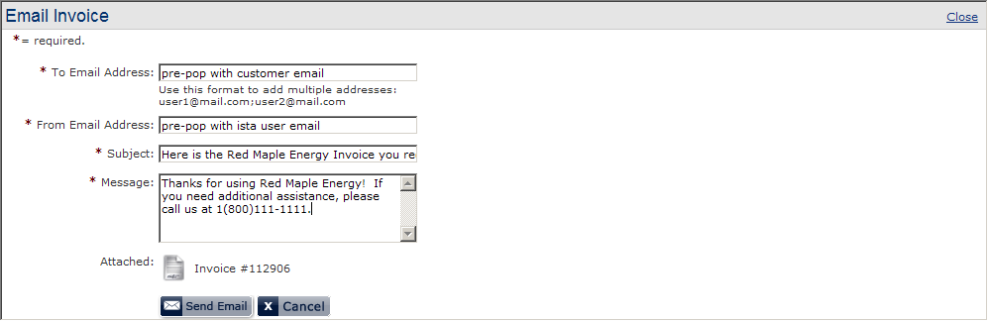

1. Once the user is satisfied with the contents of the email, pressing the Send Email button  will send a copy of the invoice to the recipient indicated in the To Email Address field. Pressing the Cancel button  or the Close link will discard the email and close the window.

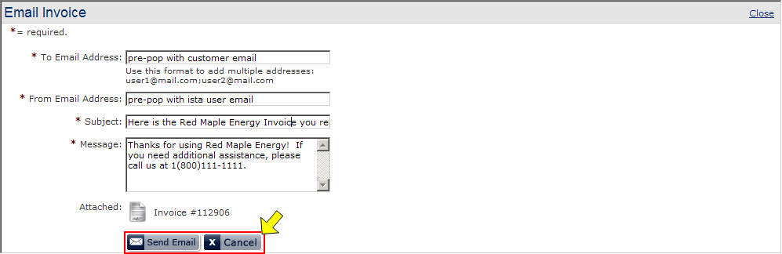

#### *To view a Customer’s Invoice:*

1. From the Accounts Receivable Summary History, click the printer icon  located to the left of the invoice number you wish to print.

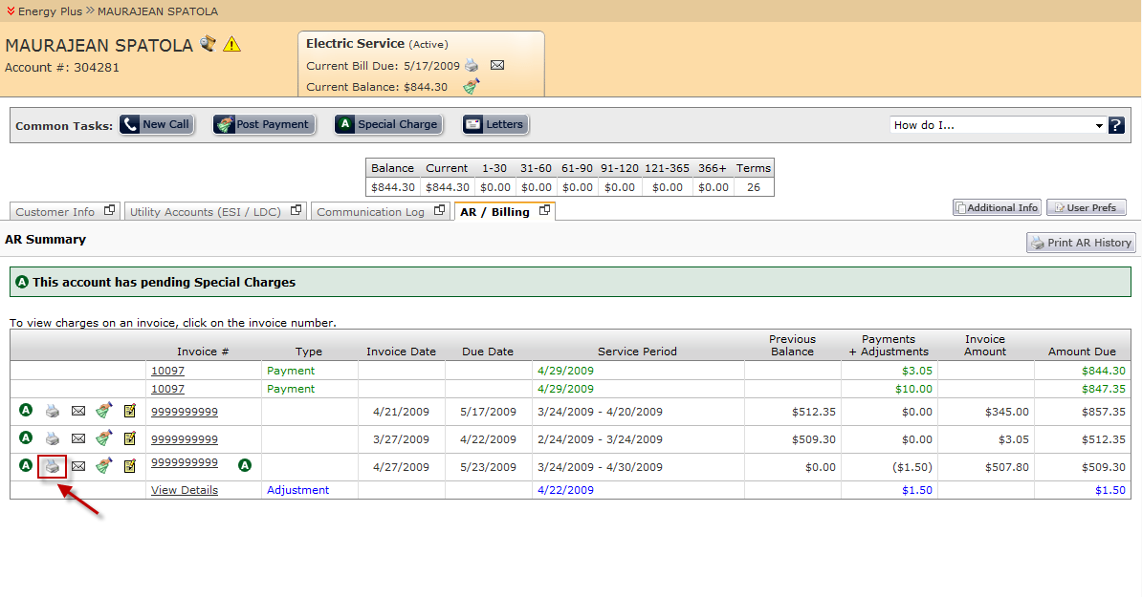

1. After the printer icon has been clicked, the invoice will be displayed in a new window.

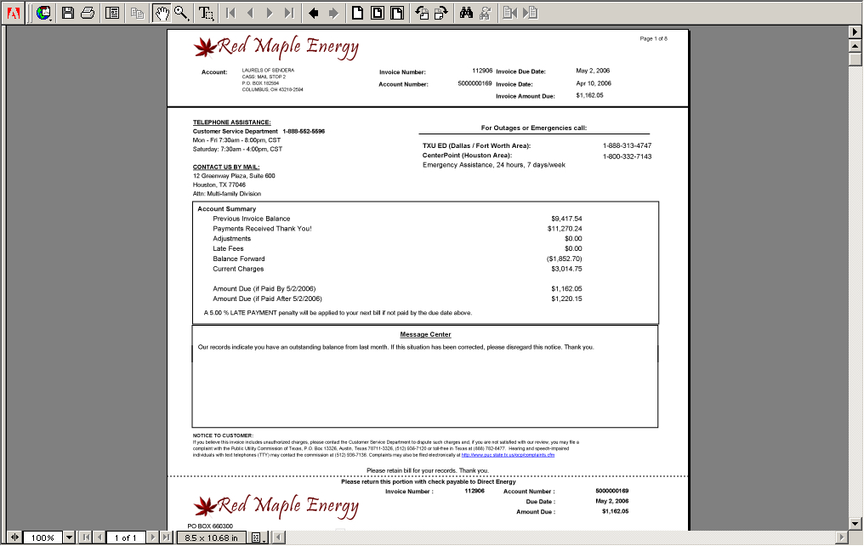

1. Once the invoice has been reviewed, the user can close the window to return to the customer summary screen. In addition, clicking the printer icon located at the top of the new window will allow the user to print the invoice.

**Note: This feature will only be available if the computer requesting the invoice has a valid printer installed and connected.

#### *To reverse invoice charges:*

1. From the Accounts Receivable Summary History, click the invoice number of the invoice you wish to view. 
2. After the invoice number has been selected, the details to the invoice will open in a panel directly below the invoice record. To reverse invoice charges, click the reverse charges icon  located to the right of the *Charge Summary* title.

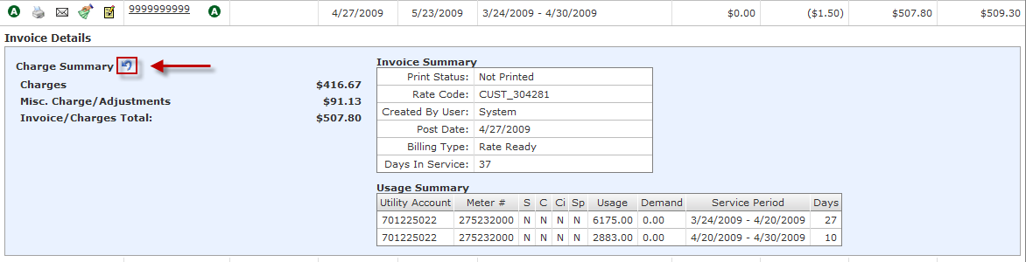

1. Once the reverse charges icon has been clicked, a new window will open allowing the user to click specific charges to reverse. Charges that the user reversed will be indicated like this: ~~~~

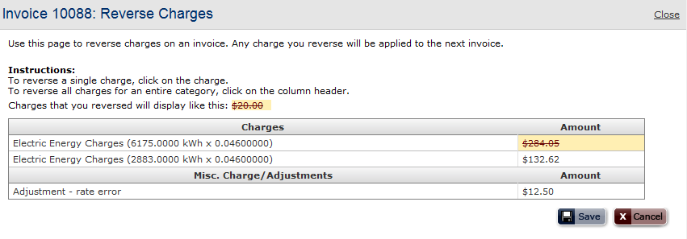

1. Click the Save button  to save the reversals. Click the Cancel button  to discard changes and close the window.

#### *To create an invoice Special Charge via AR Summary History:*

1. From the Accounts Receivable Summary History, click the invoice special charge icon  located to the left of the invoice number you wish to print.

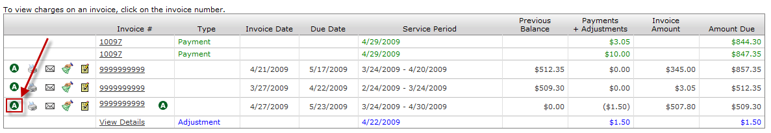

1. Once the invoice special charge icon has been clicked, a new panel will open below the invoice record. Enter the adjustment type, adjustment amount, and description into the space provided. In addition, check the checkbox for tax exempt adjustment if applicable.

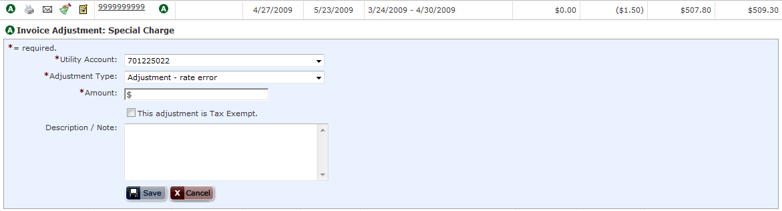

1. After the appropriate data fields have been inputted by the user, clicking the Save button  will create a special charge referencing the invoice number that this adjustment was made for. The new special charge will be reflected in the Account Receivable Alerts section as a new line item. Click the Cancel button  to discard changes and close the window.

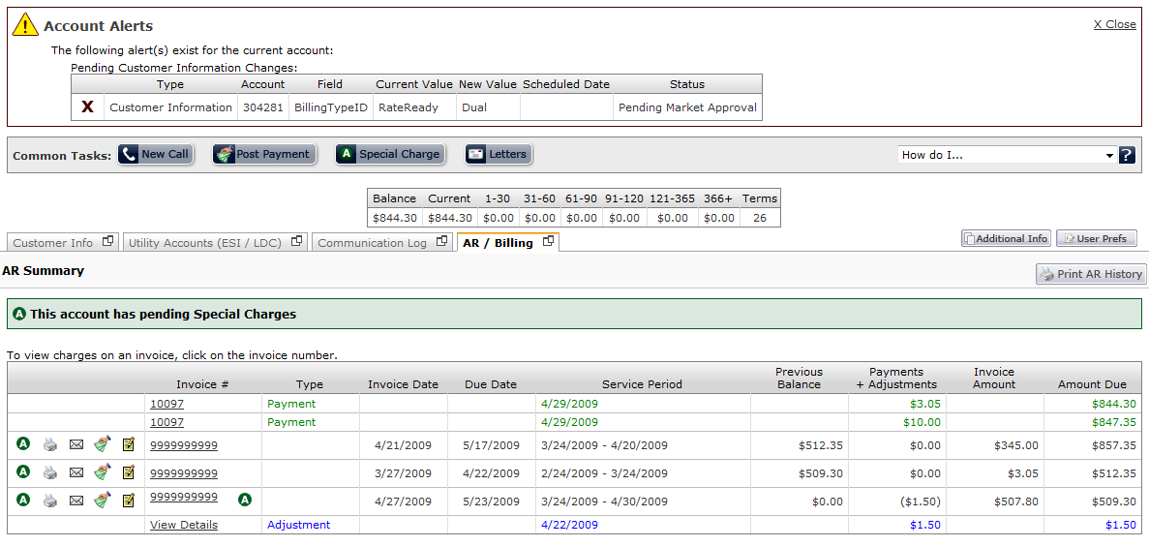

1. An Alternate way to create a special charge is to click on the Special Charge button  in the common tasks section. This reveals a similar area to enter a special charge. However, in this screen you will have to select a invoice number to associate the special charge with.

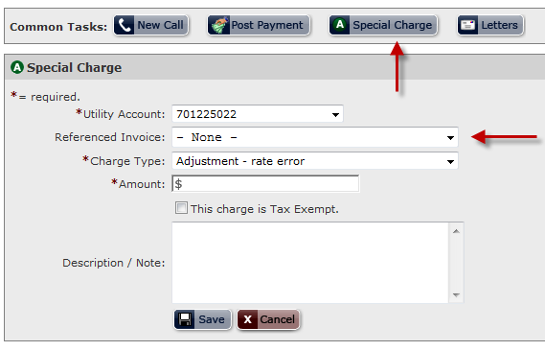

#### *To Remove a pending Invoice Special Charge:*

1. In order to remove a pending invoice special charge begin by expanding the Accounts Receivable alerts section by clicking the  icon located at the top left corner of the alerts panel.

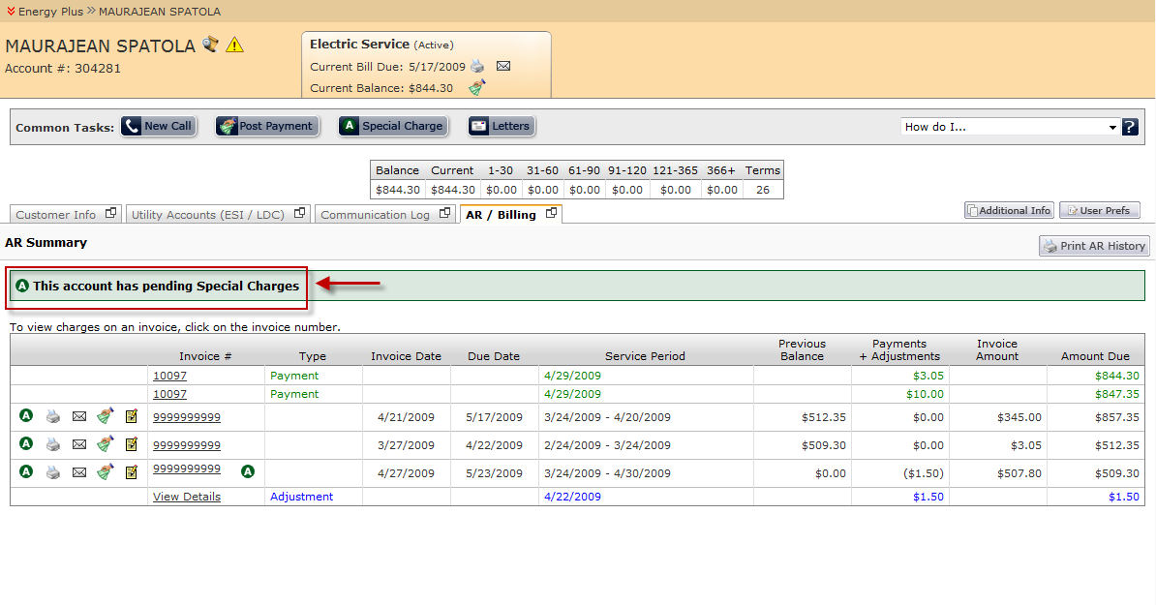

1. To remove a specific invoice adjustment, click on the ‘X’ icon  located to the left of the adjustment you wish to remove.   
   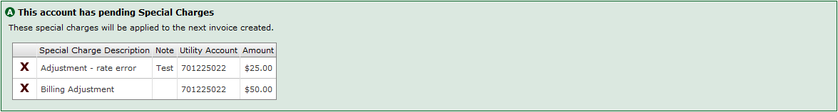
2. Once the X icon has been clicked on records you wish to remove, those records will be removed from the pending invoice adjustments table.   
   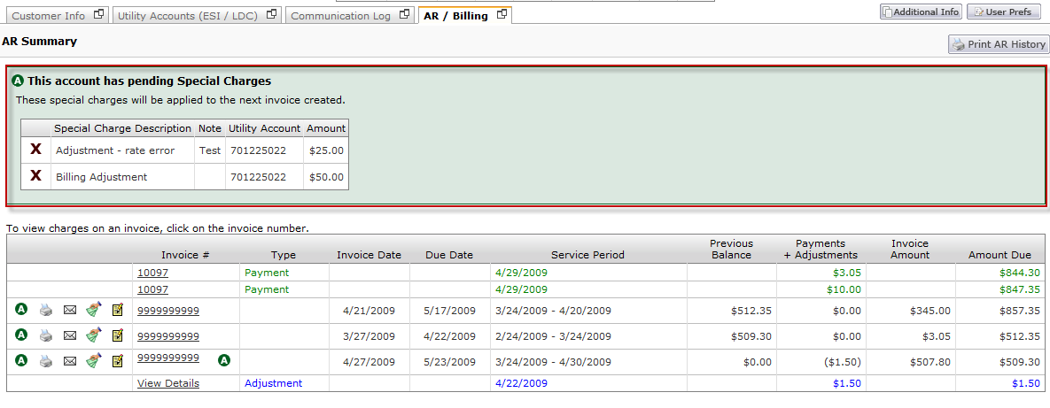

### Managing Adjustments

Occasionally a customer’s account will require adjusting. The Adjustment functionality is the part of the system where several different billing adjustment types are created. Once an Adjustment is created, depending upon which Adjustment type it is, it either sits in a holding table until the next time the customer is invoiced, or generates a transaction immediately. During the next billing process any charges in the Adjustments holding table will be “swept” into the billing process and included on the customer’s invoice in a section called “Misc. Charges/Adjustments”.

Adjustments on invoices are easily identified by the  indicator located type column and also located within the Invoice details section under the Misc. Charge/Adjustment line items.

#### *To create an adjustment on the customer’s account:*

1. Click on the activity menu -> then select adjustments.

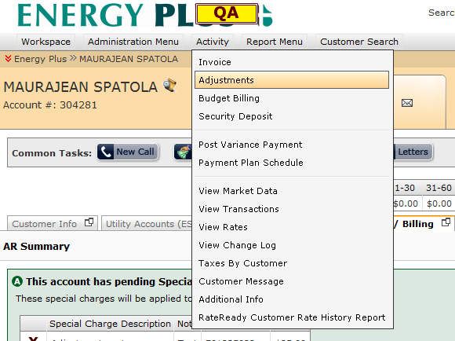

1. A new window will popup and users will need to set a adjustment type, adjustment reason, amount, referenced invoice if needed (not required), and a description if desired. When complete push the “Add Adjustment” button .

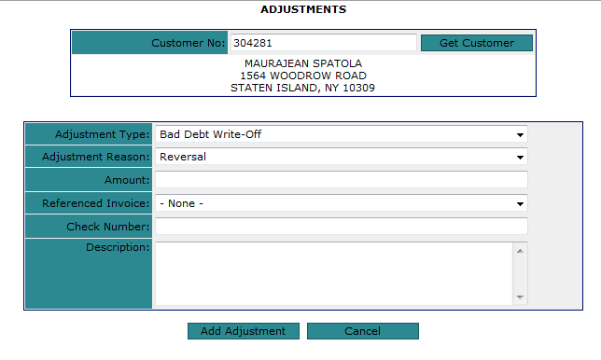

### Managing Payments

There are two ways in which payments can be posted in the system:

* FIFO – First in first out. Payments that are posted using FIFO are applied to oldest invoices first. If the payment amount exceeds all invoice amounts, the remainder will be held under unapplied payments for that customer.
* SPEC – Payments posted by invoice. Unlike FIFO where payments are automatically applied to invoices, SPEC requires that payments are tied to specific invoices.

#### *To view payment summary and detail level information:*

1. From the Accounts Receivable Summary History, click the invoice number of the payment you wish to view. Payments are indicated as ‘Payment’ under the Type column within the AR Summary History. In addition, Payment records are also indicated by a green font color.

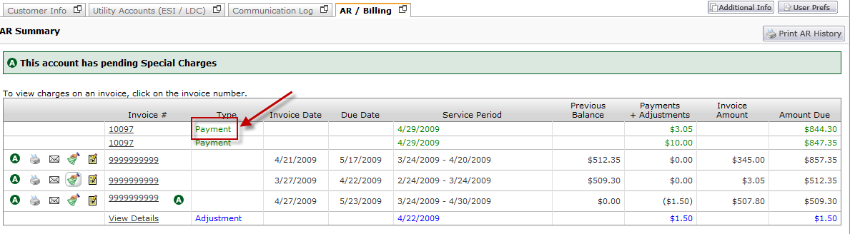

1. Once the Invoice number has been selected for the payment you wish to view, the payment details will load in a panel directly beneath the payment record.

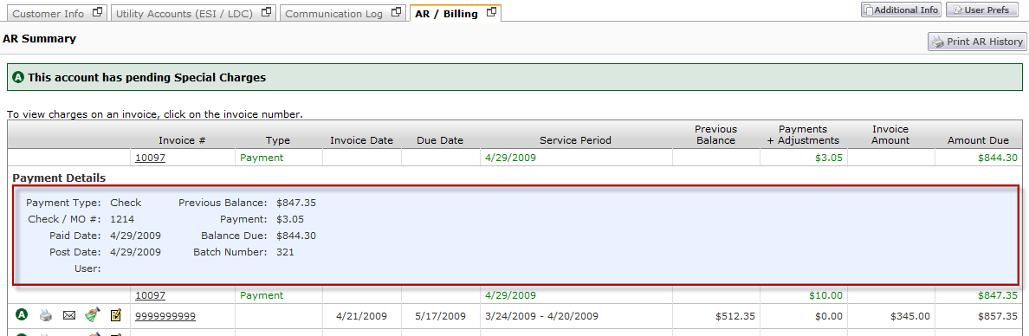

#### *To post payments to the customer invoices using FIFO:*

1. Click on the Post Payment button  located in the common tasks section of the customer summary screen.  
   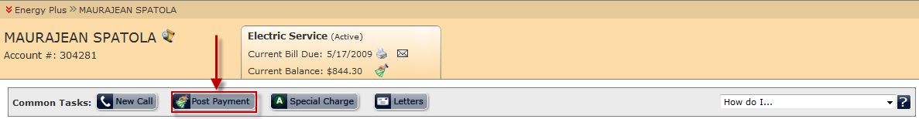
2. Once the Post Payment button has been selected, a new panel will open below the Common Tasks bar and above the Customer Summary tabs.

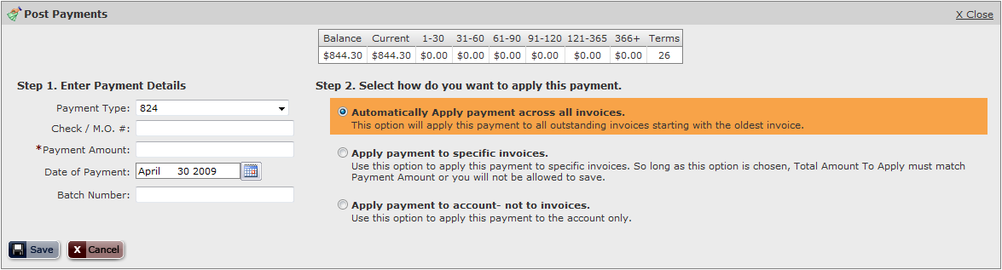

1. Enter the payment type, check or money order number, payment amount, date of payment (entered manually or through calendar controls), and batch number (if applicable) under the Enter Payment Details section.  
   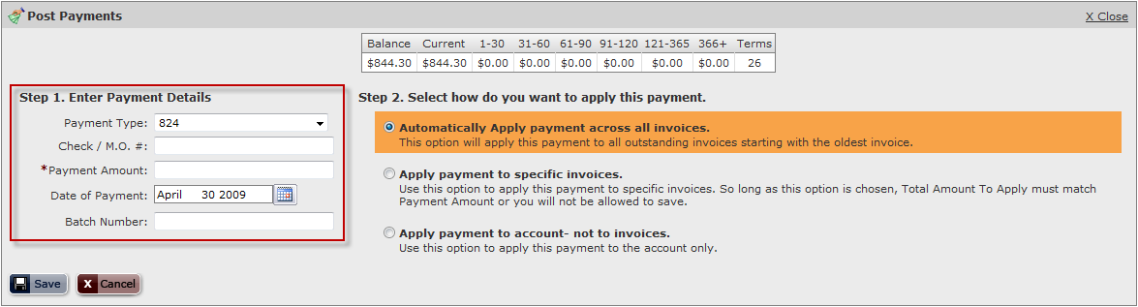
2. Under Step 2, select the option ‘Automatically Apply payment across all invoices’. 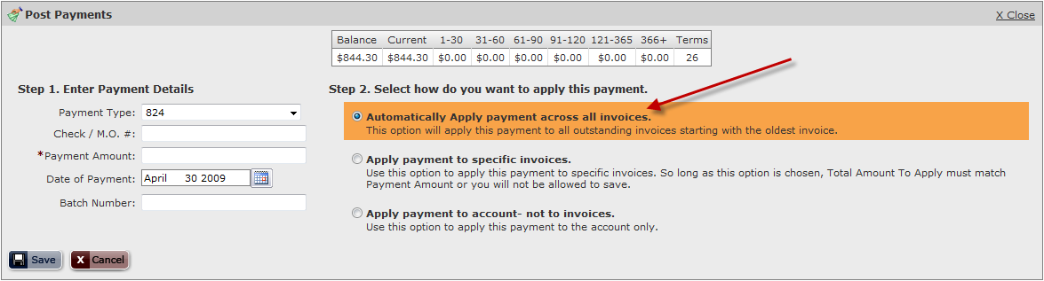
3. To post the payment and apply them to invoices using FIFO, click the Save button . To cancel the payment posting process, click Cancel  to close the panel.

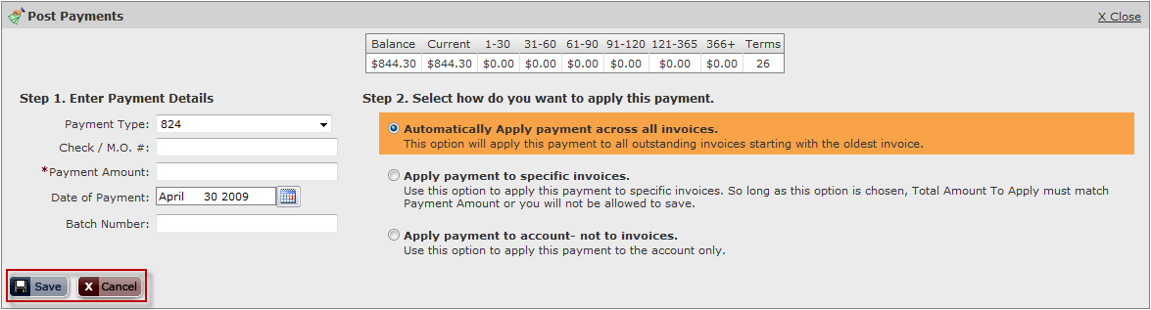

#### *To post payments to the customer invoices using SPEC:*

1. Click on the Post Payment button  located in the common tasks section of the customer summary screen.  
   
2. Once the Post Payment button has been selected, a new panel will open below the Common Tasks bar and above the Customer Summary tabs.



1. Enter the payment type, check or money order number, payment amount, date of payment (entered manually or through calendar controls), and batch number (if applicable) under the Enter Payment Details section.  
   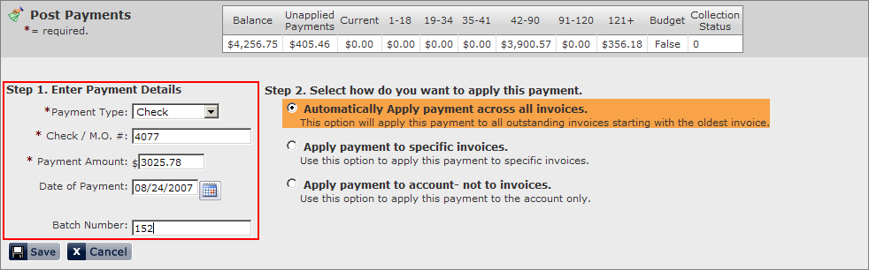
2. Under Step 2, select the option ‘Apply payment to specific invoices’. 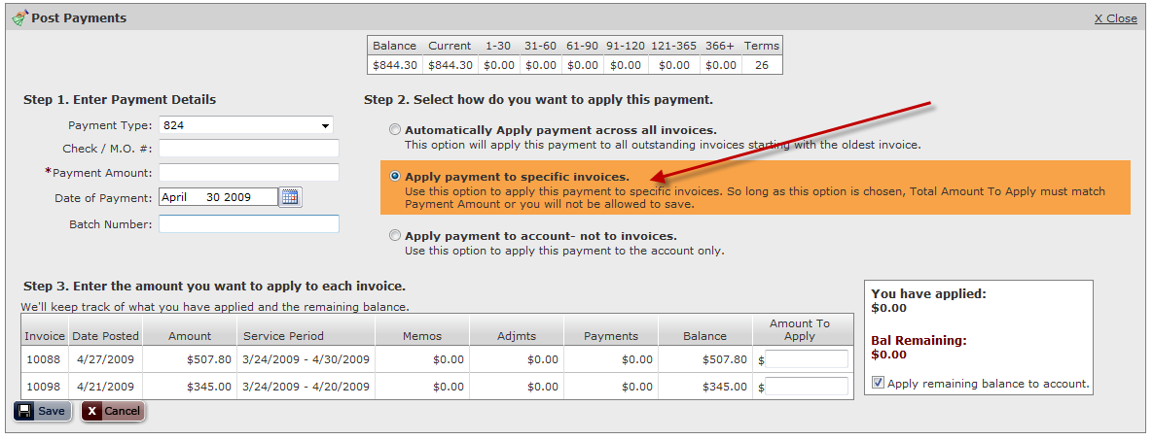
3. Once the ‘Apply payment to specific invoices’ option is selected, the panel will expand with a list of all invoices that have not yet been paid by the customer. From this new list, the user is able to input payment amounts to specific invoices. The table to the right will display the current total payment amount applied to invoices and the payment balance remaining. These values change automatically every time a payment is applied to an invoice.  
   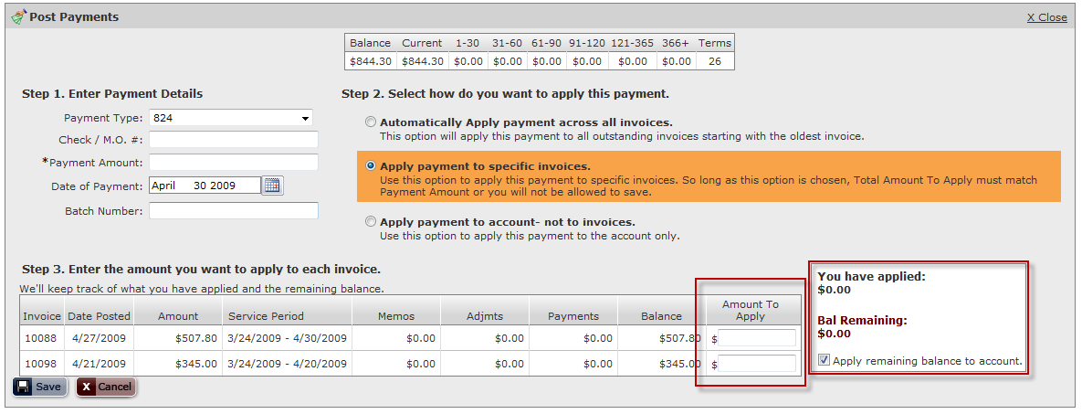
4. To post the payment and apply them to invoices using SPEC, click the Save button . To cancel the payment posting process, click Cancel  to close the panel.

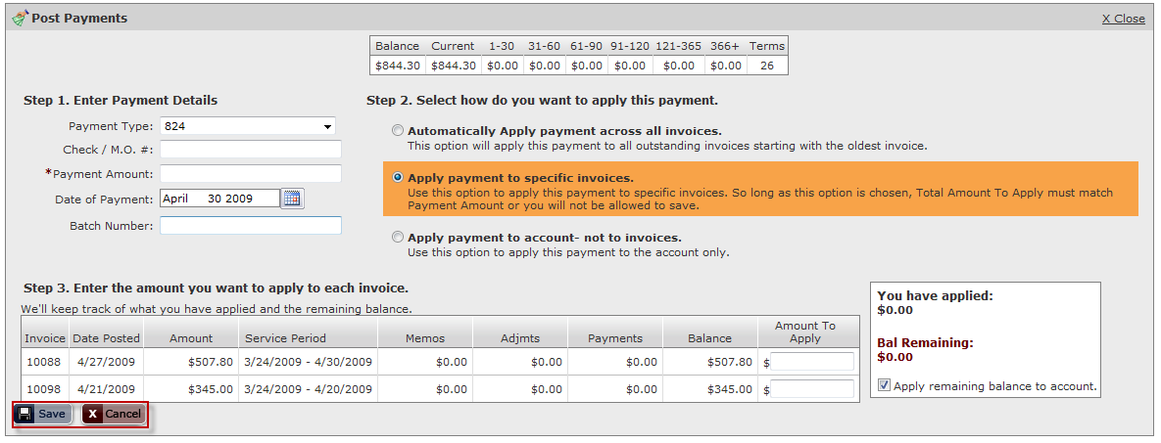

### Viewing Accounts Receivable history

#### *To Print or email the customer’s AR History:*

1. To view the customer’s AR History in a printable format, click the  button located at the top right corner of the AR / Billing tab.

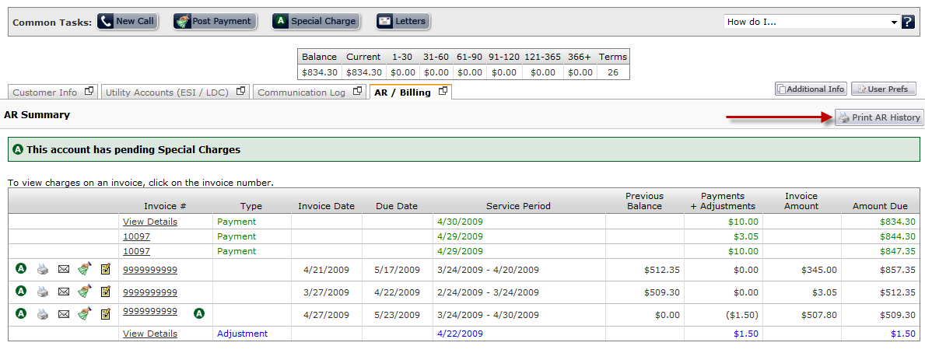

1. Once the Print AR History icon has been clicked, a new window will open which requests a Date Range and the display options of the report. The display options will determine the level of detail that is provided by the AR history report.

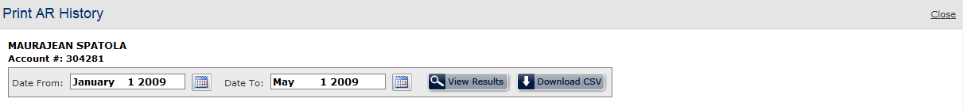

1. Populate the Date from and Date to fields either by keying dates in manually or using the calendar controls.

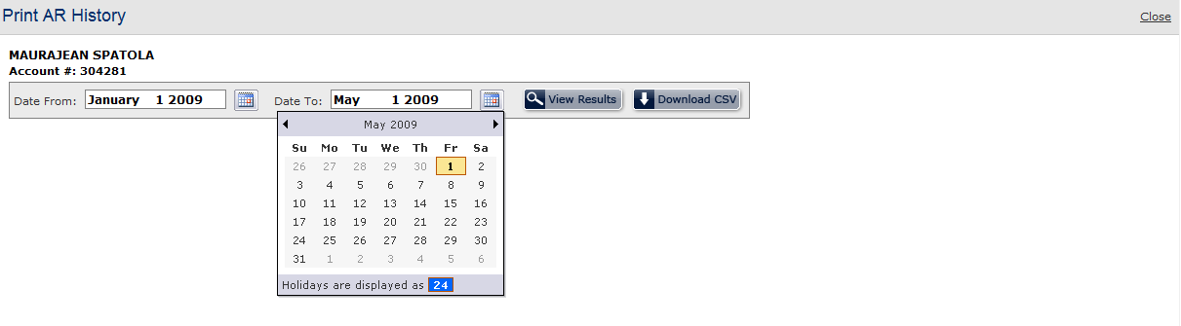

1. Once the appropriate fields have been entered, click the search button  to display AR History report. Pressing the Download CSV button  will download the results to a .csv file.

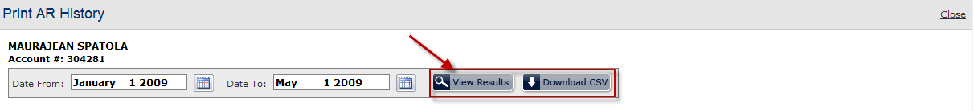

1. Upon clicking the search button, the AR History results will be displayed at the bottom of the window. To send the AR History report via email, click the email button  to begin the email process.

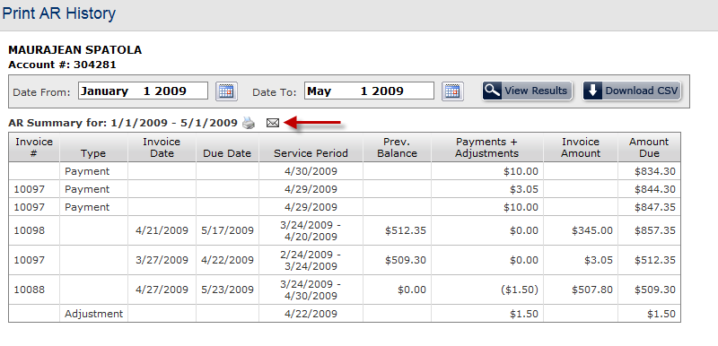

1. After the letter icon has been clicked, a panel entitled *Email Results* will open just below the Print AR History title bar. This panel will populate the Send to email address (if found under the customer’s account information), the Sent from email address (logged in user’s email address), and a general subject line. The user is free to change any of the fields in this form prior to sending the email.

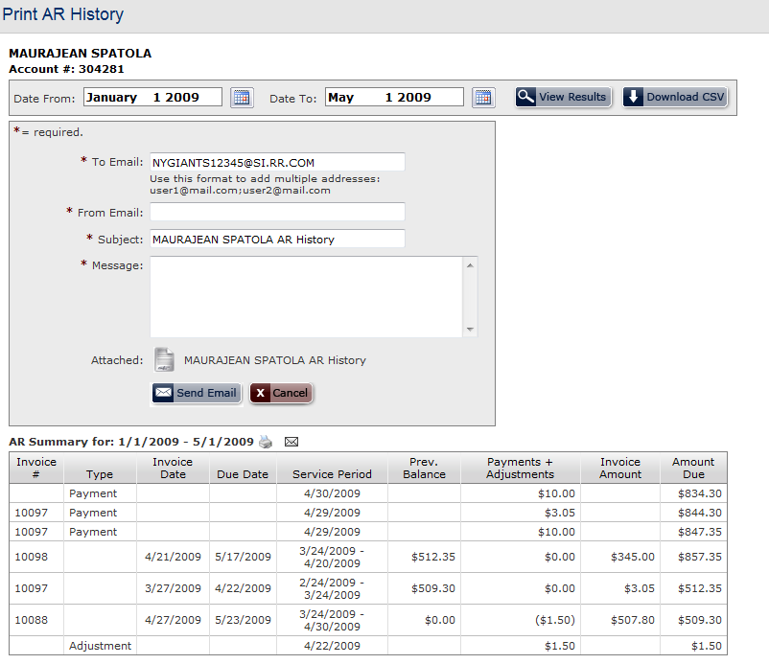

1. Once the user is satisfied with the contents of the email, pressing the Send Email button  will send a copy of the AR History report to the recipient indicated in the To Email Address field. Pressing the Cancel button  or the Close link will discard the email and close the window.

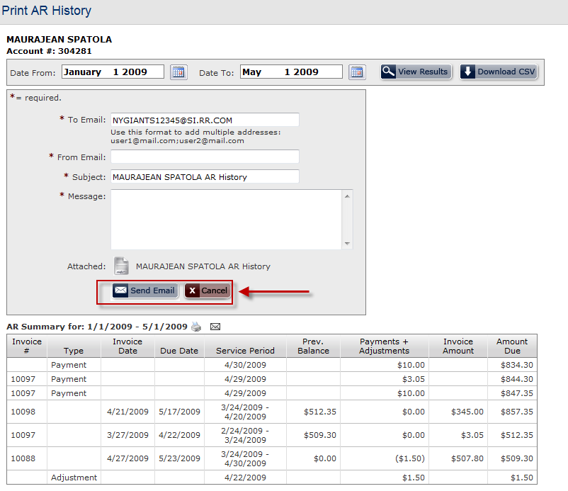

1. To print the AR History report, click the printer icon  located to the right of the Print AR History title.

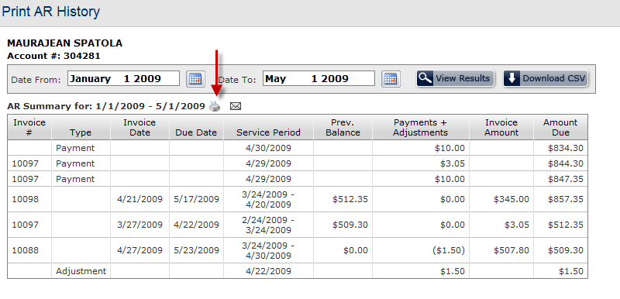

# Customer Hierarchy

Ista|net provides extensive functionality to help retail electric providers organize their customers in logical hierarchies. The customer hierarchy can be organized into two different types.

**Organization Master** – The organization master hierarchy allows the user to assign customers to a master customer. The customer hierarchy maintenance screen gives users the ability to actively manage the organizational hierarchy.

**Locational Master** – The locational master allows customers to be assigned to different service types. The customer summary screen is capable of displaying both electric and gas services for a single customer.

## Organizational Master

The customer hierarchy maintenance screen allows a user to manage the organizational hierarchy of a customer.

To access the customer hierarchy maintenance screen:

1. First, access the customer summary screen for the master customer you wish to view. Clicking Manage Hierarchy icon to the left of the master customer name will open a drop down menu.   
   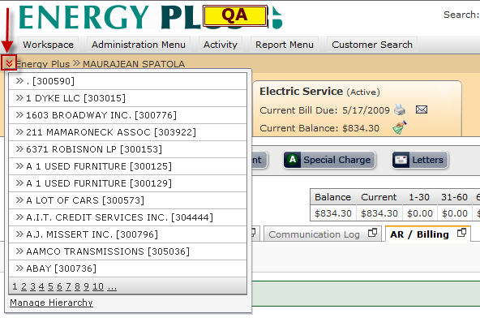
2. The drop down menu will display all customer accounts under that specific master customer. The customer summary hierarchy screen can be accessed for a specific customer by selecting the ‘Manage Hierarchy’ option under the Master Customer drop down menu.  
   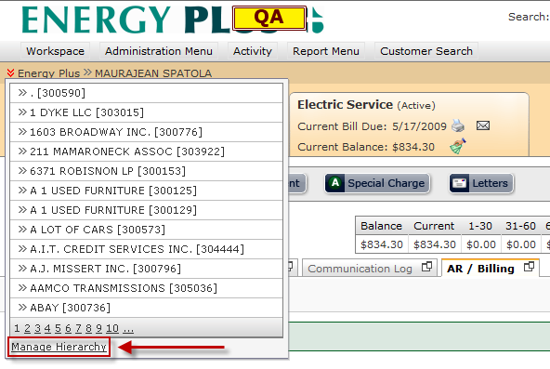

### Customer Hierarchy Management Core Features:

From the Customer Hierarchy management screen, the following actions can be performed.

**Customer Hierarchy**

* + Add customers to a master customer
  + Move customer from one master customer to another master customer
  + Create a new master level customer

**Summary Billing**

* Assign customers to be billed under a master customer

### To assign customers to a master customer:

1. Once the “Manage Hierarchy” option is selected for a specific master customer through the customer hierarchy drop down menu, the system will load the customer hierarchy management screen for that specific customer. The manage customer hierarchy screen is divided into two sections. The left panel helps the user navigate through all customers that are contained within a specific master customer. By default, the right panel allows the user to add customers to the master customer.

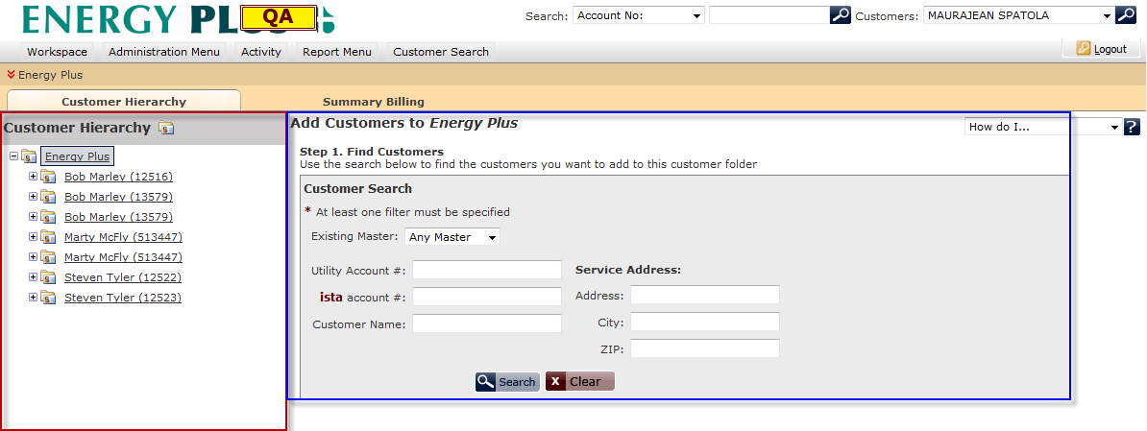

1. To add a customer to the master customer, the first step is to find a customer to add using the search panel. Enter relevant search fields into appropriate fields and press the Search button Click here to search for customers to begin your search. Pressing the Clear button click here to clear the search fields above.will clear all fields.  
   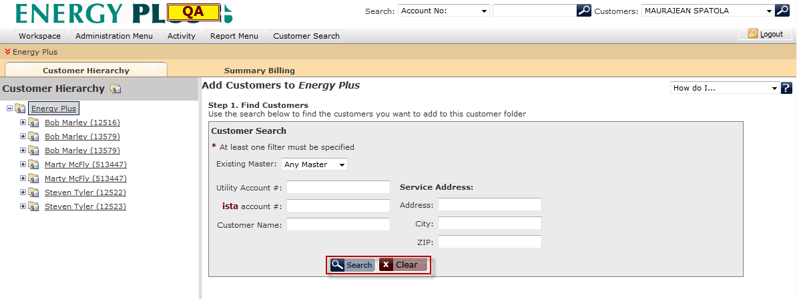
2. If search results are found, section entitled “Step 2. Select Customers” will be displayed below the search panel. Clicking on the column header will allow the results to be sorted by that column. Once a column header is clicked once, a down arrow icon  will be displayed to the right of the column name, which indicates that the results are being sorted in descending order. In addition, if there are more than 50 results returned, the results will be paginated.  
   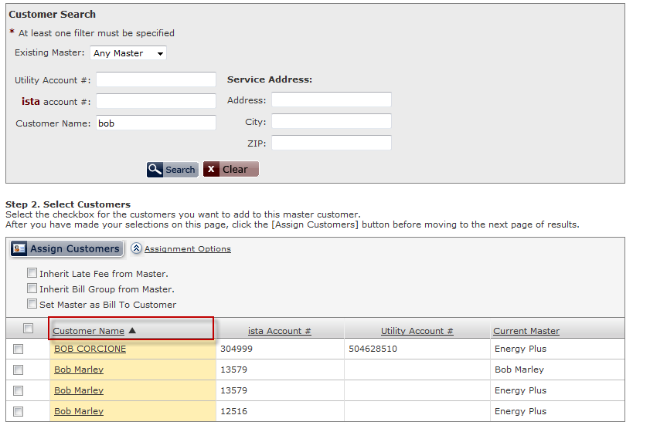

If no search results are found, an alert will be shown alerting the user that the search will have to be performed again with new search criteria.

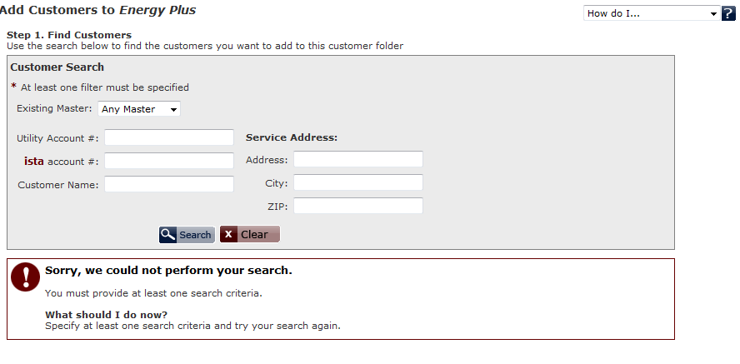

1. To assign the customer to the master customer, select the checkbox to the left of the customer name you wish to add. Clicking the checkbox to left of the Customer Name column header will automatically select all customers.

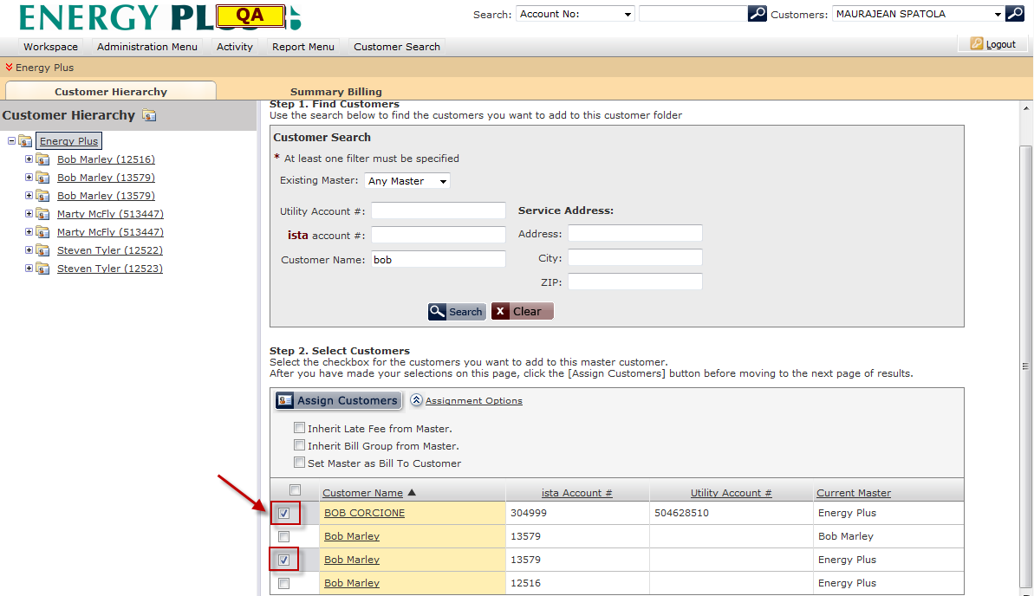

1. If you wish to have these customers inherit certain attributes from the master customer, click the Assignment Options link to the right of the Assign Customers button. The panel will expand, allowing the user to select which attributes to inherit from the master customer. If the *Set Master as “Bill To” Customer* option is selected, the *Inherit “Bill Group” from Master”* option will be automatically selected*.*

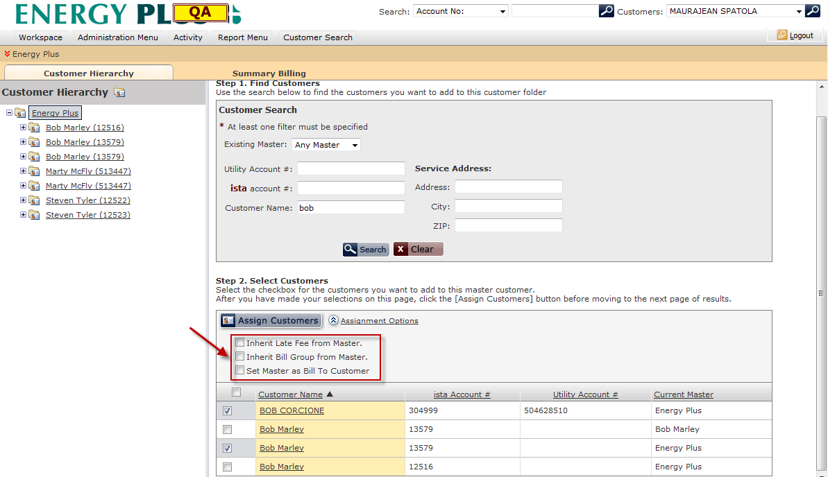

1. Once the user has selected the customers to assign and appropriate assignment options, clicking the Assign Customers button  will assign these customers to the designated master customer.

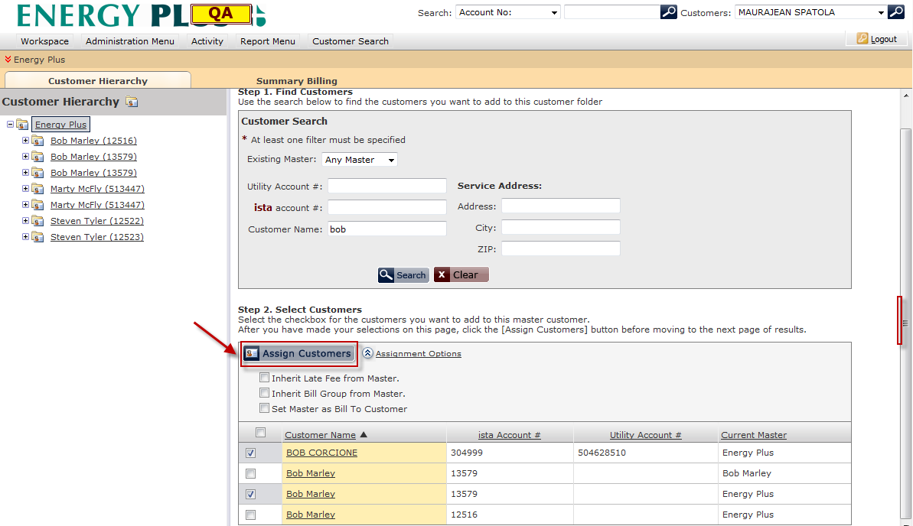

### To create a new master level customer

1. Select the master customer for which you wish to create a new master customer under. The selected customer will be highlighted in blue.

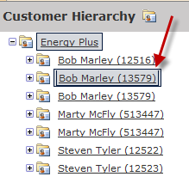

1. To open the create master customer panel, click the create new master customer button  or right click the master customer name for which you want the new master customer to be categorized under.

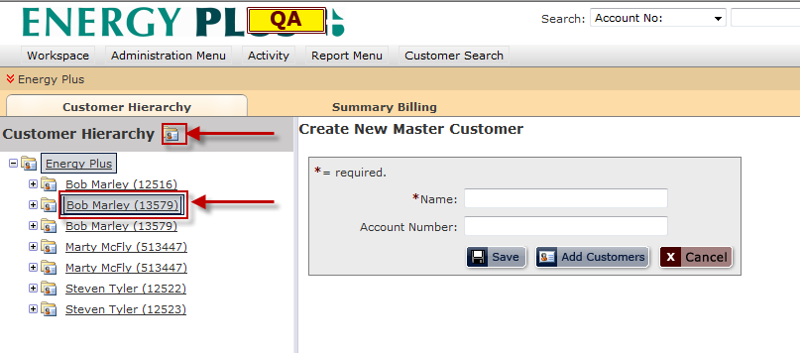

1. Enter the name of the new master customer into the field entitled “Name” and press the Save button  to create a new master customer. Press the cancel button  to exit the Create New Master Customer process and return to the default screen.

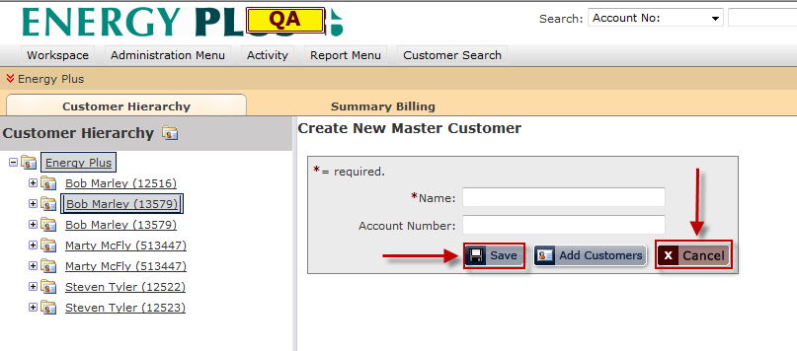

1. Once the Save button has been selected, a new master customer will be displayed below the assigned master customer. Click the Add Customers button to assign customers to this master customer.

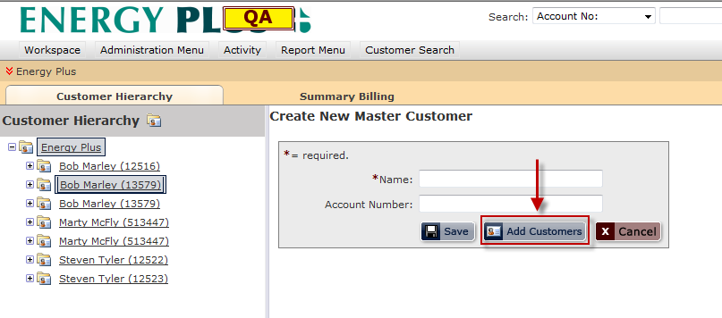

1. Once the Add Customers button has been clicked, the Add Customers screen will load. Refer to the section entitled *To assign customers to a master customer* for further instructions.

